**CHAPTER 1**

# INTRODUCTION

## 1.1 About Robots

A robot is an electromechanical device that is built to support and perform precision tasks that cannot be performed by conventional labor and continue24/7 with the same precision and accuracy. The robot is a combination of a bot that is built to support the laborious task with the internet and mechanisms. Another full form of the robot is the Random optical binary oscillating technology, which is built according to the task that has to be performed by the component.

The first robots were built to support the labor and achieve continuity in the work with different shapes and sizes. The robots are used in various industries for applications based on what is needed. Like in the manufacturing industry, robots are used for welding applications, pick-and-place work, painting, and many more. In advance, robots are built like humanoid robots, as shown in figure 1.1 below. Where the robot can perform the various advanced tasks with the support of Artificial intelligence and Internet of things, these robots are so advanced that they can answer any queries and task-related answers in real-time.

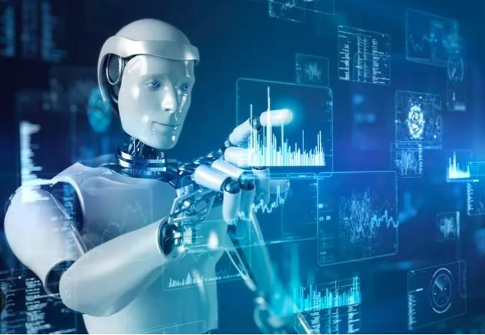

Fig. 1.1 Ideal robot for the AI task performing [1]

Looking at the above advancement in robotics, the low-cost humanoid robots are built to perform the basic tasks assigned and respond to the opponent as predefined FAQs. This robot is built using the 3D printing method so that the initial cost of the robot can be reduced for the current level. Here, various simple methods are used to optimize costs without compromising the quality of the task-related activities. These robots are built for simple tasks like line-followers, FAQs, and many more tasks.

## 1.2 Evaluation of Robots

The rise in automation led to the beginning of a modern era of robotics.TheUnimate, the first digitally controlled and programmable robot created in 1954 by **George Devol and Joseph Engelberger** as shown in the fig 1.2 below[2], They agreed on setting up a robotics company that could manufacture robots for industrial applications. This led to the foundation of a company named Unimaton, which produced in 1961 the first Unimate robot transformed production operations by handling materials and welding [2].

One of thecompaniesin 1962 manufactured a new robot that was called “Versatran”

(i.e. “versatile transfer”) [2] as shown in fig 1.2 below. It was a cylindrical robot that was

ordered by “Ford” for its production plants in Canton (Ohio, USA) [2]

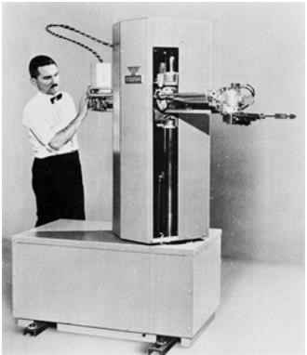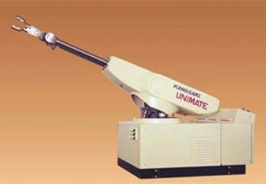

Fig. 1.2 Versatran robot [2] Fig 1.3 Unimate Robot[2]

In the 1968s-1977s the era of advancement in Robotics where Robots became more complicated and capable of performing a wide range and difficult tasks[2]. In around 1970 the microprocessor was introduced it allowed the robots greater control and programmability logic control [PLC] and some of them operated by teach pendent[2].These robots could not work a complex task and their level of versatility was not that much because the robot have their own software due to this they operate only specific tasks. It's very difficult to employ the same robot could be workingon a different task. Since the only diagnostic reports they could produce were those related to failures, which were reported by means of indicator lights, without any hint related to the cause of the failure that was left to the operator to trace.

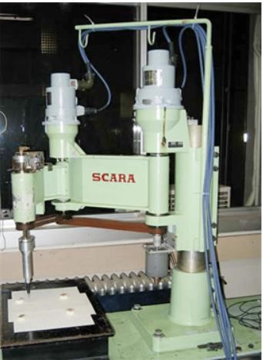

Fig 1.4 SCARA robot [2]

In 1978, a novel kinematic structure was proposed by the Japanese scientist Hiroshi Makino from Yamanashi University[2]. The structure was made of three revolute joints with parallel axes and a prismatic joint lying at the end of the kinematic chain. This type of robot structure was named SCARA ( “Selective Compliance Assembly Robot Arm”), since its compliance in the horizontal direction resulted in lower than compliance in the vertical direction[2].

The late 20th century was the era of personal and service robots designed for tasks such as cleaning, entertainment, and companionship. The sensor technology has contributed to the development of more autonomous and intelligent robots[2].

Now in the 21st century, it has entered the next stage where humanoids and cobots are in existence which are associated with humans. It withstanding their capacity there are many difficulties and ethical challenges are posed[3]. Job opportunities will be reduced as there will be replacements by robots in the sectors of manual labor. There may be privacy and security problems as robots will be associated with sensors, cameras, and many more data-collecting and processing devices.

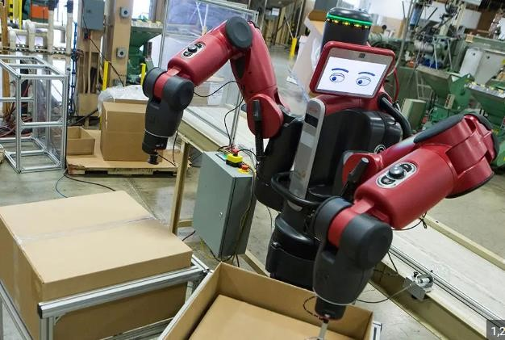

Fig. 1.5 Robotic Arms [4]

Some of the applications of the robots that were completely replaced by humans are as follows:

1. **Manufacturing**: Machine shops, (welding, Lifting, conveyors, Precision works, Medicine, and many more)
2. **Health care:** Surgeries (cardiac surgery, gynecological surgery), rehabilitation, companionship, etc.
3. **Surveillance:** It can be used for patrolling buildings and monitoring security cameras (drones, argus), etc.
4. **Hazardous places**: nuclear plants and chemical factories (high-temperature material handling, pipeline inspections, etc.)
5. **Agriculture**: It can be helpful in farming (planting, harvesting, and milking cows, etc.)
6. **Exploration:** Robots can go places that are too dangerous or inhospitable for humans, (deep sea, outer space, Volcano etc.)

**1.2.1 Present Day Robot**

The current trend and future advancements in the field of robotics AI and Machine learning are boosting the robot's ability to learn and tackle complex tasks. Looking ahead expect the robots become more work flawlessly with humans to enhance their life from several applications in the sector of industries, search, rescue, and healthcare, and hence robotics stand at the forefront of technologies[5]. This future holds the promise of robots increasing in efficiency, precision, and entirely new possibilities.

There are also seeing where robots are made with flexible materials, allowing them to interact with people more safely and navigate delicate environments.This could lead robots not just to follow instructions but also to make decisions and solve problems.

However, there are many challenges to consider. Ethical consideration surrounding robot development. Itneed to ensure robots are responsible and don’t replace human workers, and additionally, safety standards must evolve increasingly sophisticated robots.

## 1.3 Types of Robots

Robots are differentiated as per their task-performing areas in various applications, like, for example, industrial applications, which are called industrial robots.

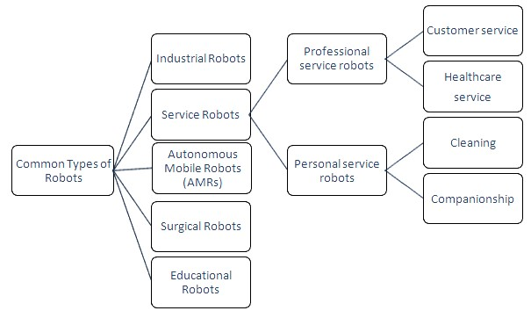

Fig. 1.6 Types of Robots [6]

**1.3.1 Industrial Robots:**

Designed for manufacturing tasks, these robots automate repetitive processes in industries such as automotive assembly lines. They excel in tasks like welding, painting, material handling, inspection, and testing. Industrial robots are especially for high durability for long periods. It can handle repetitive tasks. Industrial robots have different configurations with the most common being the articulated, resembling a jointed arm. Overall industrial robots are increasing efficiency and precision, safety in factories worldwide. While reducing human labor as shown in figure 1.7 below.

**1.3.2 Service Robots:**

These robots are intended to assist humans in various settings, including healthcare, hospitality, and household chores. They can perform tasks like cleaning, caregiving, and guiding, enhancing convenience and safety for users. It can be completely autonomous or collaborate with humans as shown in figure 1.8 below.

**1.3.3 Autonomous Mobile Robots (AMRs):**

These robots are essentially self-driving robots and navigate their surrounding without any human interference or following a fixed path. They are equipped with sensors and artificial intelligence, navigation systems to avoid the optical and plan their movement, and AMRs can move independently in dynamic environments without human intervention. They are used in warehouses for goods transportation, in agriculture for crop monitoring, and in search and rescue missions as shown in figure 1.9 below.

**1.3.4 Surgical Robots:**

The surgical robotsutilized in minimally invasive surgeries, these robots enhance precision and dexterity for surgeons, reducing patient trauma and recovery time. It typically consists of several robotic arms with tiny surgical instruments attached, a high-definition 3D camera, and with surgeon’s console. They feature advanced imaging and robotic arms controlled by surgeons, enabling complex procedures with greater accuracy. Surgical robots are still in the developing stage of technology but they havea wide range use in cardiac surgery, gynecological surgery, etc. We can expect in the future to see even more adoption as shown in figure 1.10 below.

**1.3.5 Educational Robots:**

Designed to teach programming, engineering, and problem-solving skills, educational robots come in various forms, from simple kits to sophisticated platforms. They engage students in hands-on learning experiences, fostering creativity and technological literacy from an early age. They are transforming education by making learning more interactive, especially in the science, technology, engineering,and mathematics fields.The overall goal is to make good skills full foundation for their future as shown in Figure 1.11.below.

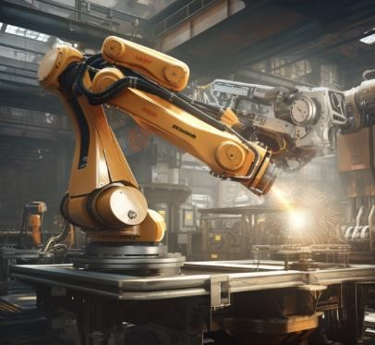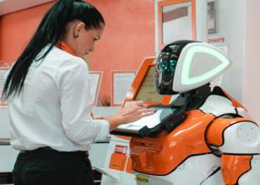

Fig.1.7 Industrial Robot [7] Fig. 1.8 Service Robot [8]

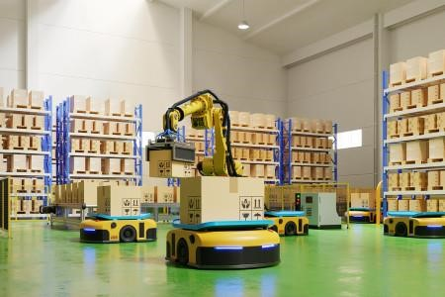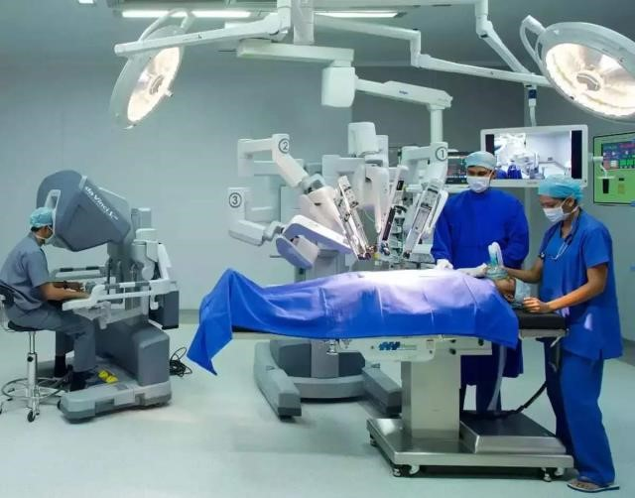

Fig. 1.9 AMR Robot [9] Fig. 1.10 Surgical Robot[10]

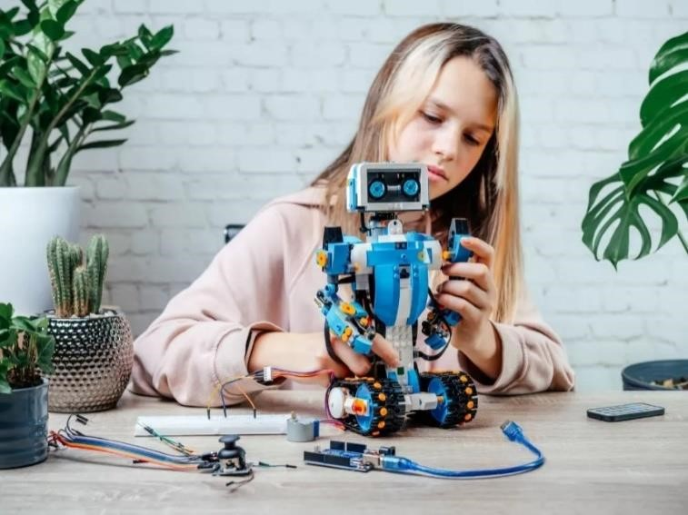

Fig. 1.11 Educational robot [11]

## 1.4 Service Robots

Service robots are autonomous or semi-autonomous machines designed to perform tasks for humans, typically in environments such as homes, offices, healthcare facilities, or public spaces. These robots are equipped with advanced sensors, actuators, and artificial intelligence to carry out various functions, ranging from simple household chores to more complex activities. Common examples include vacuum cleaning robots, delivery robots, and assistance robots for the elderly or individuals with disabilities.

Service robots aim to enhance efficiency, convenience, and safety in diversesettings, contributing to increased productivity and improved quality of life. With continuous advancements in technology, service robots are becoming more sophisticated andadaptable,ushering in a new era of human-robotcollaboration across various industries

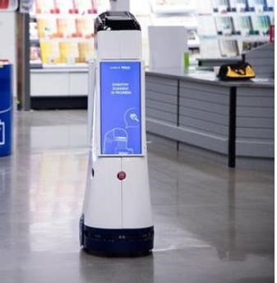

Fig. 1.12 Retail service robot [12]

### 1.4.1 Types of Service Robots

The service robots are differentiated by their applications and their specific special tasks

**A. Professional service robots are used in commercial settings to perform tasks such as:**

Logistics and delivery: These robots can autonomously transport goods within warehouses, hospitals, or even outdoors. For example, Amazon uses robots in their warehouses to move shelves of products around, which helps to improve efficiency and accuracy.

* **Customer service:** These robots can provide information to customers, answer questions, and even take orders. For example, some banks are using robots to greet customers and answer basic questions**.**
* **Healthcare:**

These robots can assist with tasks such as transporting patients, delivering medications, and performing surgery. For example, some hospitals are using robots to help surgeons perform complex procedures.

**B. Personal service robots are designed for use in homes and other personal settings.**

**These robots can perform tasks such as:**

* **Cleaning:** These robots can vacuum floors, mop surfaces, and even clean windows**.**
* **Companionship:** These robots can provide companionship to people who live alone or who are isolated.

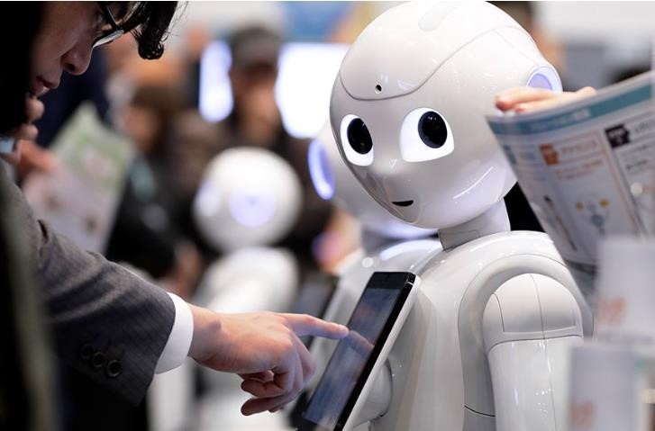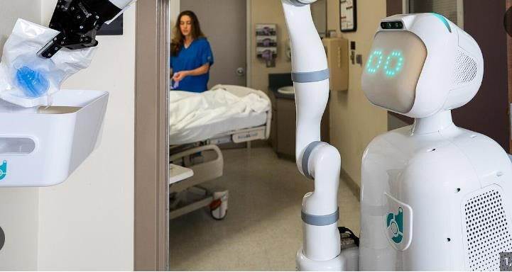

Fig. 1.13 Customer service [13] Fig. 1.14 Healthcare [14]

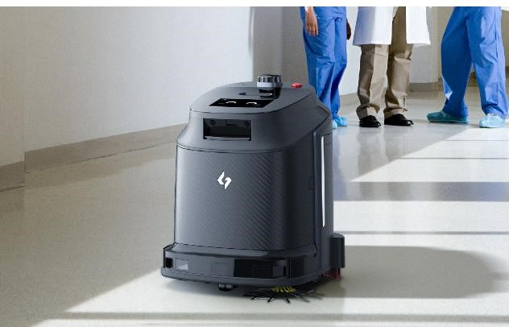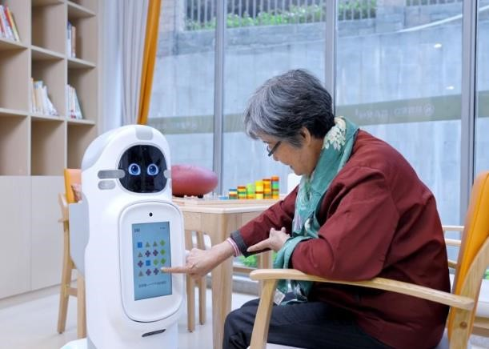

Fig.1.15 Cleaning [15] Fig. 1.16 Companionship [16]

**1.4.1.1 Humanoid Service Robot (Personal Robot):**

Based on the literature survey we are designing a human-like body of robot. It assists individuals in their home and personal work or tasks. To make it low-cost effective we are using the 3D printer for making body parts. The robot's helpful companion it interactive in a more natural way compared to traditional. It has many potential functions for daily human tasks like reminding schedules, appointments, and medications.

Robots use sensors to perceive their environment. Face detection helps recognize people while tracking follows their movements. Obstacle avoidance with infrared helps

navigate safely. Integration with robot functions allows personalized actions. Line following uses sensors to navigate paths. Text-to-speech lets robots communicate information.

Here are some of the humanoid robot features:

* **Face detection**: The extracted features are then compared against known patterns or templates of human faces stored in the system's database. This comparison helps determine whether the detected region is indeed a human face.
* **Face tracking:** In dynamic environments, where faces may move or appear/disappear from the camera's field of view, face detection systems often incorporate tracking algorithms. These algorithms help the robot keep track of detected faces over time, enabling it to maintain awareness of people's presence and movements.
* **Obstacle avoiding:** Infrared sensors detect obstacles by emitting infrared light and measuring the reflection. They are particularly useful for detecting objects at close range. The robot's control system executes the planned path while continuously adjusting its trajectory to avoid obstacles in real-time.
* **Integration with Robot's Functions:** Once faces are detected and identified, the robot can integrate this information into its decision-making processes or actions. For example, a service robot may use face detection to greet specific individuals, provide personalized assistance, or navigate around people in crowded environments safely.
* **Line following:** Line-following robots typically use sensors, such as infrared (IR) sensors or light sensors, to detect the contrast between the line and its surrounding surface. These sensors provide feedback to the robot's control system
* **Text to speech:** The process begins with the robot receiving textual input. This input can come from various sources such as user commands, pre-programmed responses, or information retrieved from databases or the internet.

## 1.5 Literature Survey

* **Kruthika K et al [17]-** This paper presents the development of 5 DOF robotic arms for feeding elderly and disabled people. The arm is controlled through GUI inputs. The principle used is the kinematics of the robot and MATLAB. Forward kinematics was used to position and orientation of an end effector. Proteus, Arduino IDE, and processing were used to test the functionality of the arm. The use of Arduino MEGA2560 I/O board, potentiometers, DC motors, and force sensors are used to enhance the functionality. This paper failsto discuss the challenges faced during the design and development of the arm.
* **He Shen et al [18] –** This paper talks about the design, development, and verification of a low-cost, lightweight robotic manipulator that can achieve human hand movements. The developed arm was of length 31 inches and of weight 7 pounds. They have used 3D printed parts using polylactic acid and nylon and used 2 servo motors and 3 brushless DC motors. It has demonstrated a comparable performance of a robotic arm to an anthropomorphic arm at a reduced cost.
* **Christina Souyoung Song et al [19] -** This study explores how Retail Service Robots (RSRs) utility, sociability, and look impact on human-robot interaction positively. The study included video clip stimuli, interviews, and empirical data gathering from food service technology and fashion industries with a sample size of 1362. It anticipates better service quality and greater acceptance of RSRs but it has limited the generalizability of the results by focusing only on three sectors i.e. fashion, technology, and food service.
* **B. Madhusanka et al [20]** – This study focuses on using eyes as an input device for enhancing human-robot interaction by developing an attentive robot eye for a service robot. Object searching development was completely implemented by OpenCV software and the CAMShift algorithm. It created object trajectories by locating the positions of objects in the video frames.

The viewing angle was limited compared to humans and the power supply through the electrical circuit was especially taken care of due to its potential limitations.

* **Z. A1 Barakeh et al [21]** – The paper discusses the rise of humanoid robots in daily life, focusing on mobility, acting, and communicating like humans in certain tasks or hazardous situations. It also proposes a review of projects utilizing humanoid robots as service robots, with a scenario framework for a humanoid robot pepper, as a service robot in the American University of Middle East. It discusses the framework of implementing pepper. It also discusses the interest of the public in service robots in Kuwait. This paper does not discuss the challenges faced and the technical aspects of the robot.
* **C. Hwang et al [22]** – This paper realizes the humanoid robotic system to service the customers in N tables, and to deliver the meal to the customer. It has 26 degrees of freedom, a wheeled vehicle with navigation ability, and a counter with order selection and task allocation. Orders from tables are transmitted via Bluetooth module. Here based on the lines on the ground, the line follower system and navigation strategy and communication are proposed.
* **M. Diftler et al [23]** – This paper discusses the mobile autonomous robot for assisting human co-workers at Jhonson Space Center with handling tools. This mentions the combination of the robots’ upper body of the NASA Robonaut system with a mobility platform which yields humanoid perfect for aiding human coworkers in a range of environments. It uses the stereo vision to locate human teammates and tools. It also has a navigation system that uses laser range and vision data to ignore objects and fellow humans. Use of tactile sensors for providing information about grasping algorithms for tool exchanges.
* **K. Miura et al [24]**- This paper presents a study on humanoid robots to evaluate assistive devices, demonstrating a decrease in torque for lifting with passive support wear. This involves pilot experiments done using a humanoid robot. The motion was obtained from the retargeting technique and the supportive effect was estimated through simulation. The limitation is, that there are no properly specified components used and functions.
* **Kanggeon Kim et al [25]**- This study describes the development of network based humanoid robots in home environment. This paper also introduces coordinated framework which provides human robot interaction. It also has face, voice and object recognition. Using task script the robot is instructed to complete the proposed tasks. Here the system simultaneously doesnot work being the limitation it can assist humans.
* **T. Nishiyama et al [26]**- This paper discusses about the development of user interface for a humanoid service robot system. The proposed system has ability of walking and four types of user interfaces. It has extended library system robot avatar agent for control and These interfaces allowed different users to control the robot in different ways, including nurses, patients, and people at remote sites.Users could select words that could be converted into actionable commands for the robot system using the network-based user interface, which translated utterances into motions for the humanoid robot .The 'FOMA' phone, a portable device with a small camera, was also taken into consideration for taking pictures to be shown on the robot's LCD screen.
* **Yoonseok pyo et al [27]**- This paper introduces a service robot with an informationally structured environment that integrates data from distributed sensors for motion and includes object detection , motion planning and human robot interaction. The information collected is stored in the online database .The object detection using RGB-D camera and motion planning through wagon. For positioning and human-system interaction, the ROS-TMS system makes use of a range of sensors, including the Vicon MX, TopUrg, Velodyne 32e, and Oculus Rift. Challenges in sensing all necessary information in complex environment needed more effective sensors.
* **Mitthias Seitz et al [28]** – This paper discusses integration of vision with gripping and object recognition. Vision is integrated into a highly redundant robot system with a tiltable camera with very acute angles and contour image processing with low quality. It has offline grasping capability. The movement of the hand, eye, and arm are according to the requirements one after the other.
* **A.Steele [29]** – This paper describes the challenges and limitations of current robotics and construction of bipedal walking system. It introduces biomimetic designs and using the locking up strategy for joints. All parts are printed using 3D printer which makes it light in weight.

But this is very complex to build all the joints and anatomy perfectly and using a wheeled robot has the required speed.

* **Zhangguo Yu et al [30]** – This paper focuses on design and development of humanoid robot, with mechanical structure and control systems. An open control architecture based on concurrent multicahnnel communication mode of CAN bus is proposed to upgrade the real time communication performance and the expansion of control system. Casting manufacturing method is used to integrate.enhancing stiffness and reliabitlity through design was the challenge and evaluating stability of humanoid motion using the zero moment point . casting was also a limitation.
* **Santiago Martinez et al [31]-** This paper discusses about developing applications for huamnoid robots using third party tools and cloud data sharing, streamlinig communication software modules for efficient development. It avoids complex communication software modules. Use of clou technologies for data sharing to facilitate intercommunication between systems. It lacks of standardization in middlewears causing delays. Bridges between those are not easily adaptable. Cloud communication is not in real.
* **Prakash K R et al [32]-** this paper presents the development of humanoids for indoor applications focusing on medical tasks. It utilized 3D printing for costeffective parts and Arduino uno for control for service tasks. It has arm moments with Arduino uno control to deliver needed medicines. Head parts are 3D printed with ABS plastic and joined with the help of nuts and bolts. The paper provides only the head part and the turtlebot surface of upper body not the movement of the robot. The next stage is carried by this projet on wheels movement.
* **Kiran Somisetti et al [33]-** In this paper the authors have presented an experiment with humanoid robots for civilians. Designed through programming and controlled by microcontrollers for the results of dof and position of robots. First solidworks software was used for design later V-rep software was used. Sensors, mechanisma, robots and whole systems can be modelled and simualted in V-rep. It was fabricated using 3D printing with PLA plastic. Rasberry pi used will give the commands for arduino to control motions. The developed robot was able to perform certain set of operations efficiently.
* **Kittiwad Kantharak et al [34]-** In this paper, the service robot named “Black

Bot” as recepionist is described. It is a three-wheeled robot controlled by mechanical actuators and various electronic sensors. It is based on dc servomotors based on differential drive. It has nonholonomic structure, containing an internal frame for the required strength and stiffness for locomotion. It has clearly designed screen for communication. Image processing provides a larger vision to the real world.

* **Ruth Stock et al [35]-** This research compares human-robot interaction with human-human interaction. The experiment carried out in a room made look like a hotel lobby intended to welcome guests. The results was positive with customer satisfaction and delight. The robot was handed by experimenter behind the screen. But all customers thought it was acting autonomously.

This paper study includes the mimic of human arm for humanoid robot. The arm is built by using PMDC motors, gear trams, breaks and motor drives. The design is having 7 dof similar to human and controlled by the microcontroller PIC 18F4580. Flexi force sensor is used to get the amount of force attached to each finger. Modular arm developed is more suitable for human interactions and can handle upto 3 kgs of payload.

**1.5.1 Summary of Literature Survey:**

By observation of the above Literature survey some of the following points are observed and motivated for this project work

* In article by Jennifer Wang [15] is a gripping story of the difficult road that goes from idea to finished humanoid service robots,
* Wang provides insightful information about the difficulties and successes faced during the design and development stages by carefully examining them, Wang skilfully handles legal issues and technical intricacies, emphasizing the necessity for multidisciplinary cooperation and creative solutions
* The research emphasizes the significance of painstaking attention to detail and iterative refinement in producing a functioning and user-friendly robot, from original ideation to prototype and testing.

This literature survey offers helpful advice for maximizing the potential of humanoid service robots in a variety of applications, making it an inspirational read for budding roboticists and engineers.

## 1.6 Problem Statement

Developing Cost-Effective Humanoid Service Robots There's a growing need for affordable and versatile service robots to automate tasks in various environments. However, current humanoid robots are often expensive due to complex manufacturing and advanced technologies.

## 1.7 Objective of Work

* To build cost-effective humanoid serving robots, using 3D printing and costeffective materials
* To serve various features like Face detection, Face tracking, obstacle avoidance, Line following, Text-to-speech, etc.
* The robot should work and integrate with suitable modes like online and offline and devices
* The robots should be working on wireless machines that can be operated in various terrains.

**CHAPTER 2**

# DESIGN AND DEVELOPMENT

## 2.1 Methodology

The methodology flow is shown in the fig 2.1. It is divided into several steps so that it is easy to analyse and develop the robot.

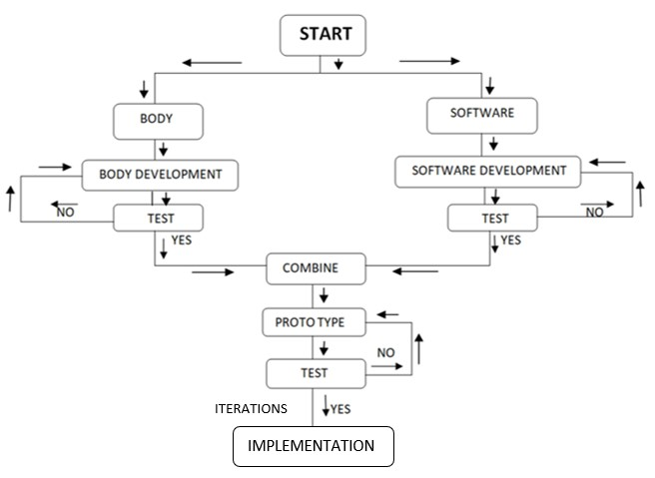

Fig 2.1 Flow-chart of robot development

Developing a robot involves various disciplines such as electro-mechanics devices and software for operations as shown in the fig 2.1 below. To ensure efficient design, construction, and implementation, the development method of the robot is divided into two parts as discussed below.

1. Body development
2. Software development

This division leads to the proper development from the head to the bottom-wheeled system and the software integration. At first, the body is developed and tested, and next the software is developed and combined with it and examined. The outcome of the test is positive with no intervention or any iterations needed, the prototype is ready and if not rechecking all the connections, integration, and finding out the trouble, resolve it and the same steps are continued.

### 2.1.1 Body Development

The body's development flow is from the design of the body to test/implementation which includes the head to the base with the wheel motion system. As Fig 2.2 shows the flow includes designing the parts in CAD. Analysing it with all the mechanisms and load it holds, next testing is carried out. If some iterations are required, are updated and again tested.

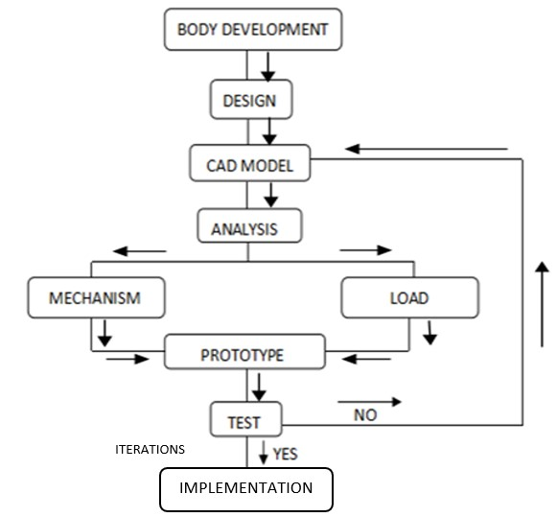

Fig 2.2 Flow chart of Body development

Firstly, the head part is considered which 3D printed and fixed with nuts and bolts is. It includes an eye mechanism and the neck part has a rotation controlled by servomotors. The torso [mid part] of the robot is made of fiber using FRP. It has arms with 5 degrees of freedom and a gripper mechanism to pick an object and provide service. The lower half of the body is designed with an extension in such a way that it is helpful to carry the objects easily on it. The lower frame is made up of mild steel and covered with wood which has a trapezoidal look. The total lower half and upper half of the body stand on the strong base which is the four-wheeled system with motors providing motion and electronics providing the power. The mentioned mechanisms are tested and if iterations are needed then done and again tested.

**2.1.2 Software Development:**

Software development is an essential part of the project to control the robot's motion and functions. As shown in the Fig [2.3] software development has multiple steps involved where the vision and voice development are divided separately. The programming is done for the application development for the motion control, eye movement control and hand movement.

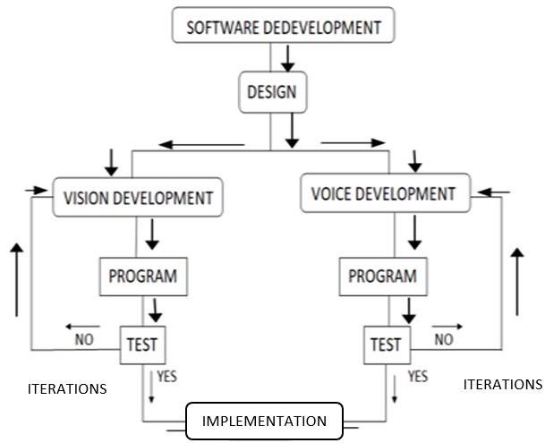

Fig 2.3 Software development

The software development includes the application built for the control of the robot’s movement and the voice assistant. The application controls the forward, backward, and turning motion of the robot and at what speed it has to move. The voice assistant helps to interact with humans. It answers the pre-commands that are already coded in it. Later the software is tested and blended with hardware and make it work in real. The microphone captures the voice and processes and converts it to text, looks for the match in the precoded commands, and if matches are found the corresponding response or actions are provided.

## 2.2 Design of Robot

A computer-aided design, or CAD, model is a computer-generated digital representation of a system or item utilizing specialized software. Before actual prototype or production, CAD models are widely used in the engineering, architectural, industrial, and product design industries to visualize, simulate, and analyze concepts. Engineers and designers can swiftly iterate, make design revisions, and assess performance aspects like strength or thermal properties because to the precise geometric information contained in these models, which includes dimensions, forms, and material properties. From straightforward 2D sketches to intricate 3D models, CAD models offer a flexible toolkit for ideation, design improvement, and teamwork across the whole product development lifecycle.

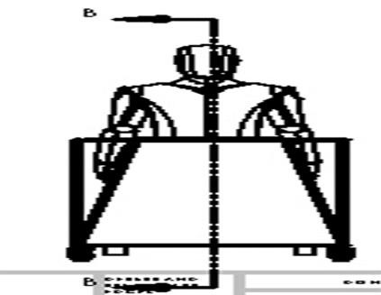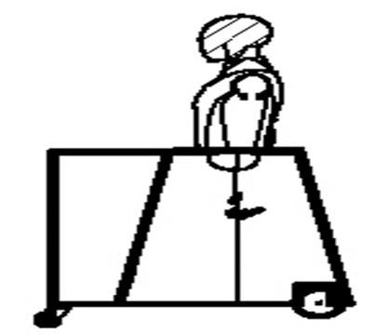

Fig 2.4 Front view Fig 2.5 Side view

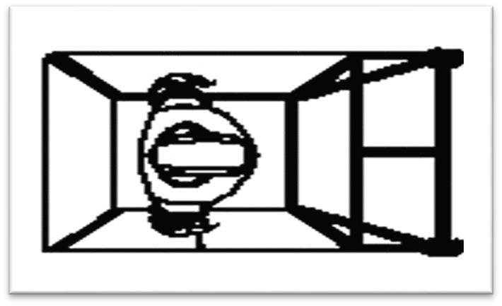

Fig 2.6 Top view

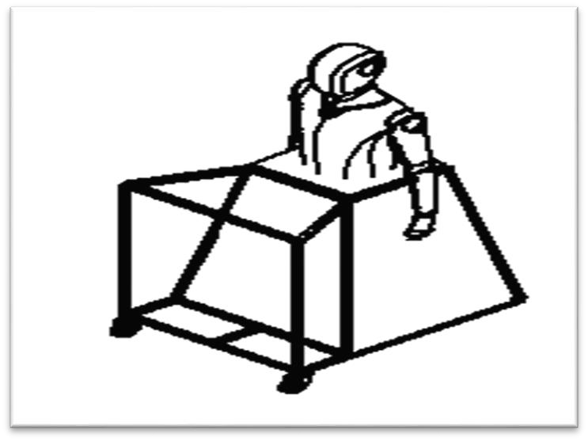

Fig 2.7 Isometric View

### 2.3 Development of Humanoid Robot Body And Mechanism

The robot body component and mechanism are divided into several parts like head, hand, eye, and lower body. The mechanism is also divided by their body parts' movement and specific tasks and functions as shown below.

**Table 2.1 Table of body robot body components.**

|  |  |  |  |  |
| --- | --- | --- | --- | --- |
| **Sl.**  **No.** | **Component Name** | **Number of components** | **Instrument Used** | **Material Used** |
| 1 | Head (Neck) | 1 | Servo Motors | PLA |
| 2 | Eyes | 2 | Servo Motors | PLA |
| 3 | Arms | 2 | Servo Motors | PLA |
| 4 | Lower body moving | 2 | wiper motor | MS Rods, plywood |

**2.3.1 Head part:**

Humanoid robots are complex systems that are characterized by high functional and spatial integration. The design of such systems is a challenge for designers and is often a long and iterative process.

The head of the robot body was discretized in several parts to achieve the shape of the head. The dimensions deduced from human skeletal data are used to create a model of our Humanoid robot in Computer Aided Design software. Modelling can be done in two different ways. Mathematical modelling formulates a governing equation for the physical event while Software modelling is to represent the physical event to the dimensions in a computer-aided design software. Moreover, the software might not have existed if there was no mathematical modelling done for an event, the software just remembers the mathematical modelling done for a similar physical event and interpolates that to the new or similar physical events. Mathematical modelling is a bit tedious and requires sufficient knowledge while the latter is a bit easier and less time-consuming. Fabrication Based on the analysis, the humanoid robot is fabricated to bring it live onto the earth. Looking in to this the material selection for the project is decided based on the price and mechanical property of the material The fabrication part is divided into mechanical aspects, electrical and electronic aspects, and computer programming.

The head part was divided into small pieces parts because it can easily fit and for internal eye mechanism setup can fit properly. The face design take from our source online so that easy and precision of the face dimensions. The whole head part is built in a 3D printed machine. The material used for 3D printed heads is PLA which has good mechanical properties like durability, and lightweight material and also reduces the weight of the body. It also produces less noise while rotating and movement of head of the robot. Due to the 3D printed part surface finish has good accuracy.

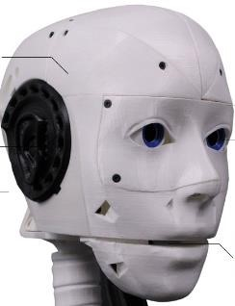

Fig 2.8 Head of the Robot [36]

**2.3.2 Eye Part:**

For the robot eye mechanism movement, we are using dual servo motors for each left and right eye. Its separate servo controls horizontal axis and vertical axis rotations, to act like a real human eye. The servo allows to the eye movement for some vertical and horizontal specific range of directions and it integrate with a small camera in that eye ball its enable for surrounding view. Another approach is to use an eye mechanism in a humanoid robot, where the rotation of the eyeball is transformed into displacement in a two-dimensional coordinate plane through simple devices. This mechanism allows for synchronous rotation of the two eyeballs in any direction, at any angle, and at any speed.

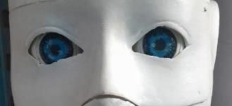

Fig 2.9 Eye and Cheek

**2.3.3 Chest Parts:**

This is the most asthmatic attraction part of the humanoid robot, here the part is extracted from the toy dummy which is manufactured using the FRP method so that all the internal components and mechanisms, of the body, can be accumulated inside the body. The mannequins (body) are made of a fabric material it is a hard material with good strength. It can hold arm weight and it is waterproof the environment can damage the body. The body gives a similar look to the human body. It can made at a low cost.

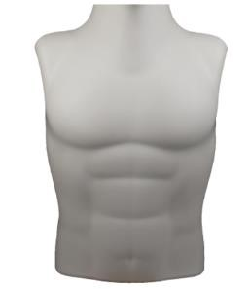

Fig 2.10 Middle part of the robot body [37]

**2.4 Mechanism of the Humanoid Robot:**

Built to resemble us, humanoid robots embody both human form and function. Their skeletons are crafted from light yet super-strong materials, while joints with different movement options grant them lifelike mobility. Electric motors, powerful fluids, or compressed air act as their muscles, fuelled by batteries, external cords, or even built-in generators.

**2.4.1 Eye Mechanism:**

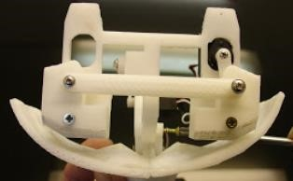For the robot eye mechanism movement, we are using dual servo motors for each left and right eye. Its separate servo controls horizontal axis and vertical axis rotations, to act like a real human eye. The servo allows to eye movement for some vertical and horizontal specific range of directions and it integrates with a small camera in that eyeball its enable for surrounding view. Another approach is to use an eye mechanism in a humanoid robot, where the rotation of the eyeball is transformed into displacement in a two-dimensional coordinate plane through simple devices. This mechanism allows for synchronous rotation of the two eyeballs in any direction, at any angle, and at any speed.

Fig 2.11 Eye mechanism

**2.4.2 Head (Neck) Mechanism:**

The robot neck mechanism crucial role. It has a single servo motor which provides the robot the ability to move its head in various directions like humans and help to see the surrounding environment for the action by tilting its head left and right direction to expand the view. The series connected joints like a human spine which support the neck and head for rotating in desired directions. The servo is connected to a gear for controlling a rotation speed head. Due to the light weight of the 3D printed head material, it reduces the weight of the servo motor and ensures the balance of the moving head. And less weight of the head mechanism prevents self-injuring itself.

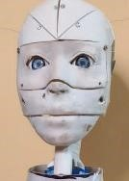

Fig 2.12 Head mechanism

**2.4.3 Hand mechanism:**

To act like human arms the way humanoid robots should a modular to design and efficient degree of freedom so that can it mimic human arm and hand motions. To perform motions like human arms it should have 7 DOF and 7 DOF out of 5 DOF for only arm.

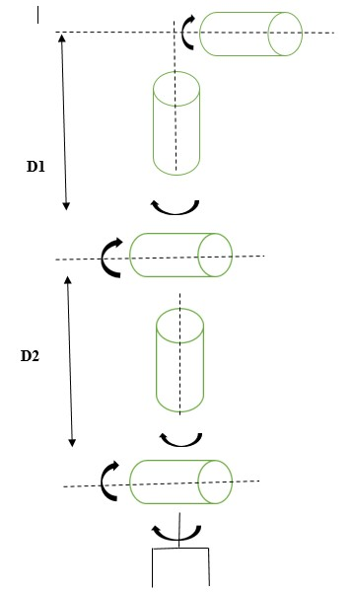

Fig 2.13Model for the Arm to get the trajectory [38]

The human upper limb to shoulder hand the weight of the arm it could be 1.4 kg and the length measures 60 cm from shoulder to wrist with dimensions and proportions similar to adult human hands. The arm has 5 independent DOFs, each of them actuated by a dedicated servo motor. Each arm joints have different rotation and linear motions. Due to the human arm-like structure, the angle or joint range movement is also limited.

#### 2.4.4 Lower Body

The lower part of the robot body is a frame that has the most strength. It is framed using mild steel. Mild steel has very good mechanical properties such as high impact strength, high tensile strength, ductility, and more. The main property the project has concentrated on and considered is its great weld ability and flexibility by which it has been shaped with ease accordingly. The lower body of the robot is given the trapezoidal shape planned to provide support for the upper body stand. It is a tapering trapezoidal prism wider at the bottom. It has an extension on which the load is carried.

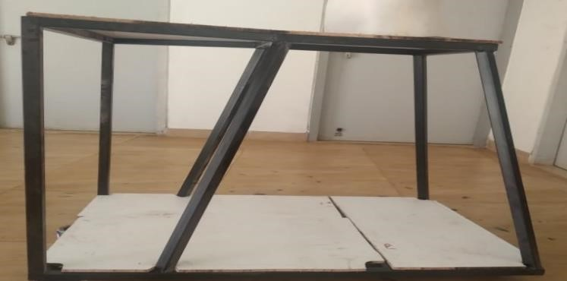

Fig 2.14 Lower Body frame

The frame is covered by the wood. As it is a lightweight dry material. Properties that make it remarkable are such as its strength, toughness, its wide availability and it is inexpensive as plywood is collected from the remains in the college. The lower body is also a holonomic structure. The battery from the base, any connections from sensors to the board, or any electronic components adopted in the robot can be placed inside this lower body.

### 2.5 Movement of Complete Robots

The generation of motion for humanoid robots is quite different from that of standard robots because of the large number of joints, coupling between joints, and redundancies. Our basic assumption is that humanoid robot kinematics can be embedded into human body kinematics. The humanoid’s kinematics do not need to reproduce every aspect of human kinematics (indeed, this would be impossible), but should reproduce some properties of the human body. The principles governing whole-body coordination in humans are far from being understood and implementations on complex systems, such as humanoids, are missing, especially besides walking. The balancing with multiple rigid contacts, the robot's upper body standing and balancing with supported by a lower body rigid table-like structure. The robot's hands intend to reach for an object on the table the robot will recognize that the distance is sufficiently far away, and the task cannot be achieved without compromising the balance. The head and eye have a combined motion like the human example when the human eye sees in any direction the head rotates that direction with the eye. The lower body has a rear wiper motor which is connected to the wheel and provides high-power rotational motion and the front wheel are caster wheel that guides the robot in the desired direction.

## CHAPTER 3 DESIGN AND CALCULATION OF THE HUMANOID ROBOT

**3.1 Anthropometric data for the human body:**

“Antro” means human body and “metric” means measurement, it is combined to gather Anthropometric data. Anthropometry is the science concerning the measurement of human body dimensions for making a human-structure body and products. The designer and engineers use the anthropometric data to reduce error and get the perfect shape and size of the human body using this data depending upon the continent which they are dealing with. Anthropometric human body data resolve the issue of non-statistic body dimensions which is required to design any component related to the human body [38].

### 3.2 Diagram of the robot

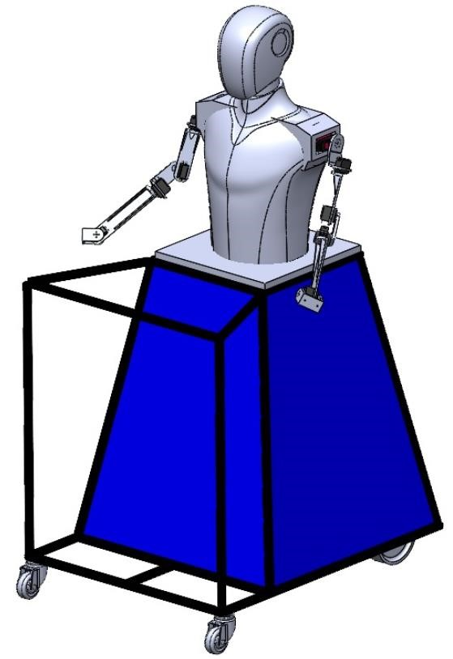As shown in Fig 3.1 below CAD Model of humanoid robots requires Human body dimensions to design. It depends on the continent and structure of the design. In design, the various dimensions of Head, body, and arm dimensions are collected from the Anthropometric data sheet.

Anthropometric dimensional data for the human body help to study a human various body parts' movement or motion like a 2 DOF planar limb movement and horizontal plane and precise motion of shoulder and elbow joints. The mechanical linkage lets the user make combined extension and flexion movements of the shoulder and elbow joints to reach specific targets in the horizontal plane. The linkage is modifiable to align its high-quality servo motor joints with the centers of rotation of the shoulder and elbow joints.

Fig 3.1 CAD Model of Robot

### 3.3 Head Dimensions

When incorporating anthropometric data into the design of a robot head, it's essential to leverage key human anatomical measurements for both practical and aesthetic purposes. These measurements encompass the head circumference, face width, and height, which determine the overall size and proportions of the robot's head. Additionally, details such as interpapillary distance guide the correct placement of the eyes, while nose dimensions and mouth width contribute to realistic facial features. Considering ear size and position relative to the head is also crucial for a lifelike appearance. These anthropometric insights provide a foundation for creating a robot head that mirrors human proportions effectively, ensuring it appears authentic and functions appropriately in various contexts. Tailoring these measurements to specific design objectives and ergonomic requirements is important, particularly if the robot head will engage closely with humans or perform specialized tasks requiring precise spatial considerations [38].

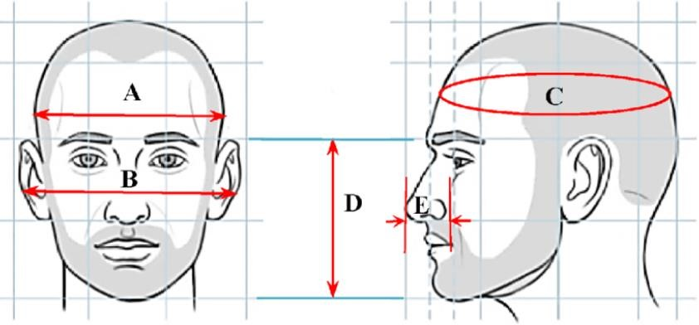

Fig 3.2 Anthropometric Measurements of Human Head [39]

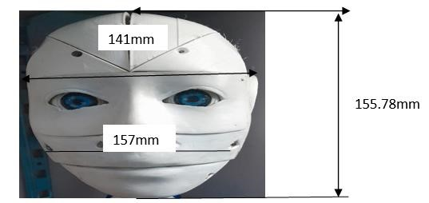

Fig 3.3 Robot Head Dimension [39]

**Table 3.1 Table of anthropometric data dimensions of the Human Head [39]**

|  |  |  |  |  |
| --- | --- | --- | --- | --- |
| **Serial Name** | **Section Name** | **Mean(mm)** | **Min(mm)** | **Max(mm)** |
| A | Head Breadth (Front head) | 155.1 | 141.0 | 167.12 |
| B | Ear-to-Ear Distance | 175.23 | 155.78 | 180.56 |
| C | Circumference (Horizontal  perimeter of the head) | 570.54 | 582.3 | 541.02 |
| D | Length (Middle of the forehead to chin) | 157.23 | 142.89 | 168.35 |
| E | Height of the Nose | 32.13 | 29.39 | 33.24 |

Anthropometric measurements of the human head deal with the measurement of Circumference (horizontal perimeter of the head), Head Breadth (The maximum bilateral distance between the right and left sides of the head.), and length (Middle of the forehead to chin), Ear to Ear Distance, and Height of the nose. The study is done on fifty people of different ages, and the value of the measurements is also shown in Table

### 3.4 Anthropometric Data of Mid-Body (Shoulder, Arms, Forearm, Sleeve)

Anthropometric data encompasses various measurements that provide insights into human body proportions and dimensions. These measurements include Forearm-Forearm Breadth, which denotes the width of the forearm at a specific point, typically near the elbow joint. Forearm-hand length measures the distance from the elbow to the tip of the hand, revealing the forearm's length relative to the hand. Wrist length indicates the segment length between these joints along the forearm. Lower Arm and Upper Arm Lengths specify the lengths of these respective arm segments, crucial for understanding limb proportions. Shoulder-Waist Length measures from the highest shoulder point to the natural waistline, reflecting vertical upper body dimensions. Lastly, the Sleeve Inseam, important in garment design, measures the sleeve length from the armpit to the cuff, ensuring proper fit and comfort. These anthropometric measurements are vital across disciplines such as ergonomics, fashion design, and anthropometry studies, enabling the creation of products and environments that cater to diverse human body sizes and shapes.

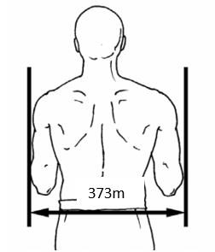 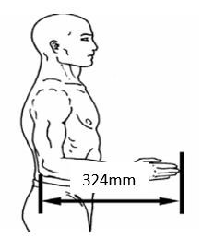

Fig 3.4 Forearm-Forearm Breadth [40] Fig 3.5 Forearm-Hand Length [40]

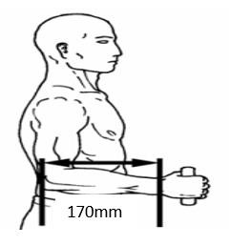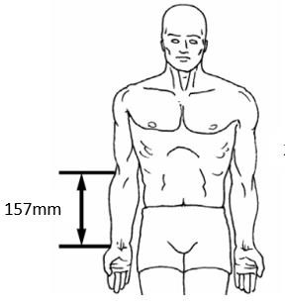

Fig 3.6 Elbow-Wrist Length [40] Fig 3.7 Lower Arm length [40]

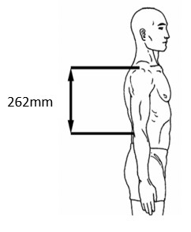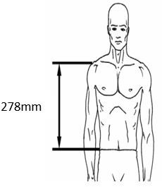

Fig 3.8 Upper Arm Length [40] Fig 3.9 Shoulder-Waist Length [40]

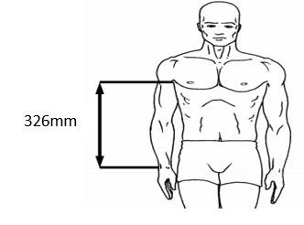

Fig 3.10 Sleeve Inseam [40]

**Table 3.2Table of anthropometric data dimensions Mid Body (Shoulder, Arms, Forearm, and Sleeve) [40]**

|  |  |  |  |  |  |  |  |
| --- | --- | --- | --- | --- | --- | --- | --- |
|  | Forearm-  Forearm  Breadth(mm) | Forearm-  Hand  Length  (mm) | Elbow-  Wrist  Length(mm) | Lower  Arm  (mm) | Upper Arm  Length(mm) | Shoulder-  Waist  Length(mm**)** | Sleeve  Inseam  (mm) |
| Mean | 468.5 | 442.9 | 262.5 | 234.4 | 311.9 | 351.5 | 443.3 |
| Std.  Deviation | 34.7 | 23.4 | 15.4 | 15.5 | 16.7 | 22.8 | 29.5 |
| Minimum | 373 | 324.0 | 170.0 | 157.0 | 262 | 278 | 326 |
| Maximum | 609 | 546.0 | 334.0 | 312.0 | 370 | 442 | 553 |

For the mid body of robot for designing the data extract from the Asian anthropometric data of male body. Comparing male body size and shape with the female body the male body have simple body shape and size not like female body have the complicated and many curvy shape and lots of measurements come. The above table is anthropometric data dimensions of male mid body. The male body of anthropometric data offers advantages for robots needing size, strength, and a larger work envelope.

### 3.5 Manufacturing

Manufacturing is the main step to be followed to develop the service robot. Manufacturing transforms the materials into the finished components of the robot, ready to assemble. It can be said that, manufacturing is the backbone and crucial process in the development of the robot. The main procedure of manufacturing the service robot imbibes 3D printing and FRP.

#### 3.5.1 3D printing

It is also known as additive manufacturing, where a three-dimensional object is created using CAD model. It tremendously gained importance in the engineering field because of its high benefits. It provides design freedom, individualization and easy execution of the ideas. Because of 3d printing, prototype can be developed faster, it also enables customization and improvement in the quality of the product it prints. It is easy to print complex geometry with high precision and accuracy. The process of 3D printing includes the CAD design of the model, extracting stl file, selecting the material, choosing the parameters, creating the code and building the product. The printer Creality ender 3 is used in the project to print the parts of the robot as this is the most popular and affordable printer. It has gained widespread importance because of its combination of quality construction and decent print volume.

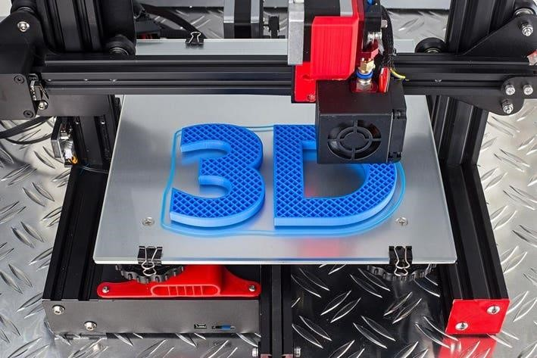 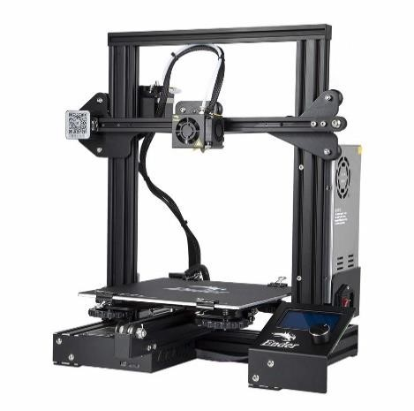

Fig 3.11 3D printing [41] Fig 3.12 Creality 3 3D printer [42]

The humanoid service robot project's integration of 3D printing provides variety in prototypes, allowing for quick component iteration and customization. It can optimize both functionality and aesthetics by customizing parts to the robot's specific needs by utilizing 3D printing technology. In the end, 3D printing allows us to design a humanoid service robot that can be customized to meet the requirements of various users.

#### 3.5.2 Robot Head

The head part of the robot is 3D printed. It is divided into small parts so that the parts are properly printed with accuracy. And made easy to assemble with nuts and bolts to resemble a human head. The various parts are lower back, mouth, eyeglass, forehead, side ear support, mouth, jaw as shown in fig. [3.12] and top fullback, top skull left, top skull right, as shown in fig.[3.13] below.

The files with the CAD models are converted to .stl files. After converting the file, it is transferred to machine and the machine set up is done with proper parameters for the build process. The material selected to print the parts of the head is PLA (Polyactic acid) filament due to its favorable properties such as high strength, low cost and ease of printing. Building the part continues layer by layer. 20% infill density was chosen to balance structural strength and material efficiency with the layer height of 0.2mm. The printing process is carried out on the Creality ender 3 3D printer. Once the build is complete it undergoes post processing of surface finishing by sandpapering and applying an epoxy layer on it.

Later the different parts of head are assembled together to get the required shape of the head of the service robot using M3 nuts and bolts.

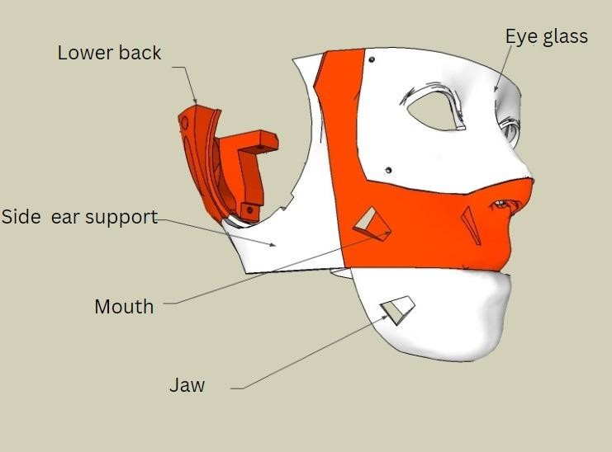

Fig 3.12 Parts of face [43]

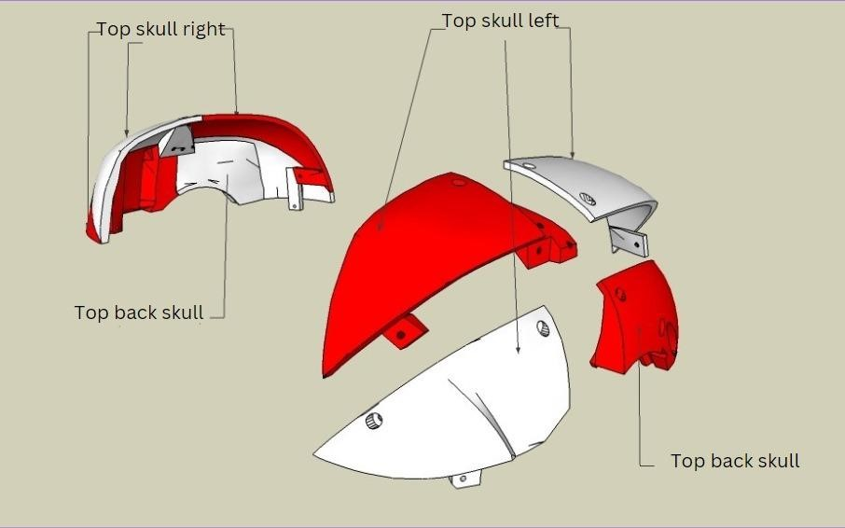

Fig 3.13 Parts of the head [43]

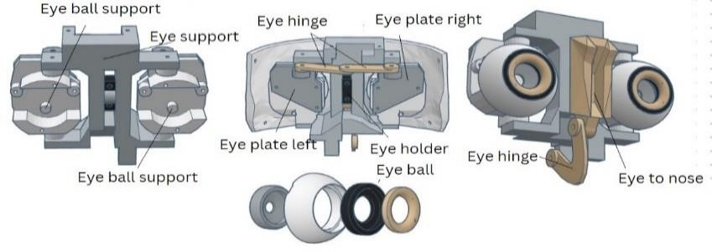

Fig 3.14 Parts of the eye [43]

As shown in the Fig. 3.14 above, the eye components are printed accordingly. It constitutes various parts to be assembled like eye hinges, left and right eye plates, eyeballs, eyeball support, eye to nose, eye holder. These are separately printed and the eyes are painted to look to a human eye. The parts undergo the post processing techniques of sandpapering for the smooth finish and its proper functioning. Later the eye parts are assembled using M3 nuts and bolts carefully.

#### 3.5.3 Arm

The arm is of 5-degree of freedom each featuring 5 rotary motions. Using the 3D printing technology the arms are printed. The design includes upper arm (biceps), forearm and wrist with shoulder joint, elbow joint and wrist joints for achieving several range of motions. The arm was designed using the solid works software. PLA filament was selected for its material strength with 5% infill chosen to optimize the weight. The 3D printing process was conducted on a Creality 3 3D printer with layer height of 0.3mm. each joint consists servo motors, one with the shoulder joint motor of 60kgcm, another 2 motors of biceps and elbow joint motors of 15 kg-cm and the other two motors for wrist and fore arm rotation motors of 10kgcm.

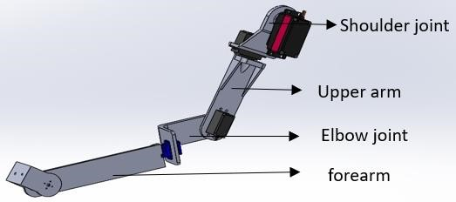

Fig 3.15 Parts of Hand

Assembly involved securing the joints with screws and ensuring the proper alignment for smooth motion. Manufacturing began with the creation of digital 3D model of arms. Later G-code was generated and the parts of the arm were printed carefully. After printing is completed, the parts are aligned properly and assembled with nuts and bolts. As shown in fig[3.15] the parts of arm consist of the shoulder joint part which is first printed and then the upper arm, sequentially elbow joint, and forearm are printed.

**3.5.4 Torso**

The mid body of the robot is the part that will resemble human’s chest and abdomen. It is manufactured using FRP (Fiber reinforced plastic). FRP is a composite material made of a polymer matrix reinforced with fibers. Fibers are usually glass, carbon, aramid or basalt. Others are also used such as paper, wood, boron or asbestos have been used. It is essential to maintain and to strengthen the existing infrastructure. It is the best suited for any design program that demands weight savings, precision and simplification. Hence, the body is made of FRP. Achieving human-like aesthetic is crucial for enhancing robot’s ability to interact with humans.

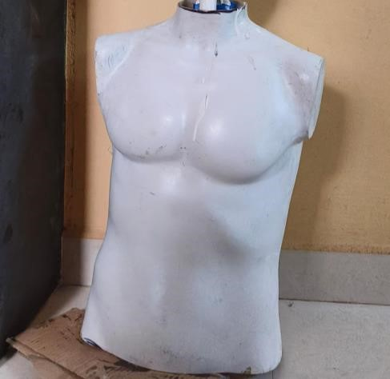

Fig 3.16 Mid-body of the robot

The first step in the fabrication process was to create a precise clay sculpture that captured the expressions and anatomical details unique to a human face and body. After that, a mold release agent was applied to this sculpture to stop the adhesion of the next materials. To ensure precise replication of the fine features, layers of silicone rubber were applied around the sculpture to produce a negative mold. The negative mold was filled with layers of fiberglass cloth that had been appropriately shaped. The fiberglass cloth was then saturated with polyester resin combined with a catalyst, creating a robust and long-lasting composite. The composite was carefully removed from the mold after a suitable amount of time had elapsed for hardening, exposing the modeled human shape. The finishing touches, which included painting for realism and sanding for smoothness, were applied to achieve the desired appearance.

**3.5.5 Lower Body**

The objective of the fabrication of the lower body is to provide structural support and stability while accommodating essential components. The trapezoidal prism shape was chosen for its ability to house internal components efficiently and distribute weight evenly. Mild steel beams were used in the fabrication process, along with a variety of hand tools like drilling, and grinding machines for shaping and cutting. Arc welding has been done to join the beams. The lower body's trapezoidal prism shape was created by welding together mild steel components. Because MIG welding is so versatile and can create strong, long-lasting welds with little distortion, it is one of the most welding processes used. The design stage of the construction process started with conceptualization of the shape and the beams were formed by the design. After the beams were put together and oriented in the correct positions, welding was done to secure them.

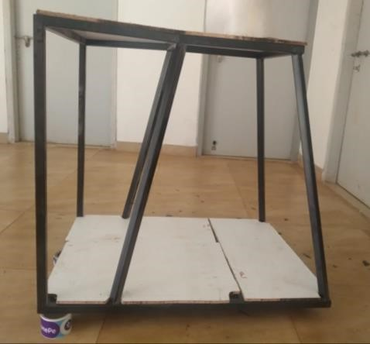

Fig 3.17 Lower body

**3.6 Structural Design of Lower Half**

The project has a cone-shaped lower half rather than normal human-like legs because of the complexity of the calculation and centroid verification methods. The cone structure provides the robot stability to hold the excess weight of the upper body just in case and will allow easy and low-cost maintenance and build materials to structure it. The hollow characteristic given to the robot will give sufficient space to fit the other important connections like the battery, and electronic components required for the robot to run. The overall performance of the robot will be enhanced due to the hollow and rigid nature of the frame used in the construction of the lower body thus providing a low-cost alternative to the lower body construction.

**3.6.1 Calculations: CAD data**

Using the simulation capability of CAD modeling software, the stability data of the robot can be easily obtained. Important parameters like the center of mass and the moment of inertia are provided by this feature. The stability and functionality of the robot depend on these characteristics. Furthermore, the manufacturing process is facilitated by the simulation data, which provides exact measurements and insights required to create the robot precisely.

Center of mass: (millimeters)

X=-98.94

Y=329.07

Z=0.00

Principal axes of inertia and principal moments of inertia: (grams* square millimeters) Taken at the center of mass.

|  |  |  |  |
| --- | --- | --- | --- |
| Lx | 0.01 | 1.00 | 0.00 |
| Ly | -1.00 | 0.01 | 0.00 |
| Lz | 0.00 | 0.00 | 1.00 |

|  |  |
| --- | --- |
| Px | 287862575.80 |
| Py | 391850586.30 |
| Pz | 393904421.78 |

Moments of inertia: (grams* square millimeters)

Taken at the center of mass and aligned with the output coordinate system. (Using positive tensor notation.)

|  |  |  |
| --- | --- | --- |
| Lxx = 391847381.91 | Lxy = 577245.45 | Lxz = 798.63 |
| Lyx = 577245.45 | Lyy = 287865780.25 | Lyz = 1129.17 |
| Lzx = 298.63 | Lzy = 1129.17 | Lzz = 393904421.72 |

Moments of inertia: (grams square millimeters)

Taken at the output coordinate system. (Using positive tensor notation.)

|  |  |  |
| --- | --- | --- |
| Lxx =933296599.78 | Lxy =-162214126.71 | Lxz = 338.15 |
| Lyx =-162214126.71 | Lyy =336810408.80 | Lyz = 997.74 |
| Lzx =338.15 | Lzy =997.74 | Lzz =984298268.14 |

**CHAPTER 4**

## MECHANISM IMPLEMENTATIONS & TESTING

### 4.1 Mechanism

The project work is considered incomplete without having a considerable working mechanism and its testing. In this chapter we are going to describe the different mechanism involved in the project and how they function in the project. It has different mechanisms involved and are mentioned below.

Various mechanism in the humanoid robot -

* Eye
* Hand
* Motion
* Line Following
* Machine Vision

The mechanisms mentioned plays a crucial role because to perform a particular task given, making the robot versatile, adaptable and more helpful. The mechanisms involved are explained below.

**4.1.1 Eye Mechanism**

The eye mechanism creates a motion similar to that of a human eye by using a series of links for the “X” and “Y” motion of the eyes. Two “SG90” Servo motors are used to accomplish the whole “X” and “Y” motion. The servo motor is as shown in the Fig. 4.1 below and the rear view of eyes with servo is shown in Fig 4.2 below.

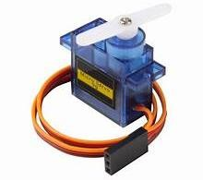

Fig 4.1 SG90 Servomotor [44]

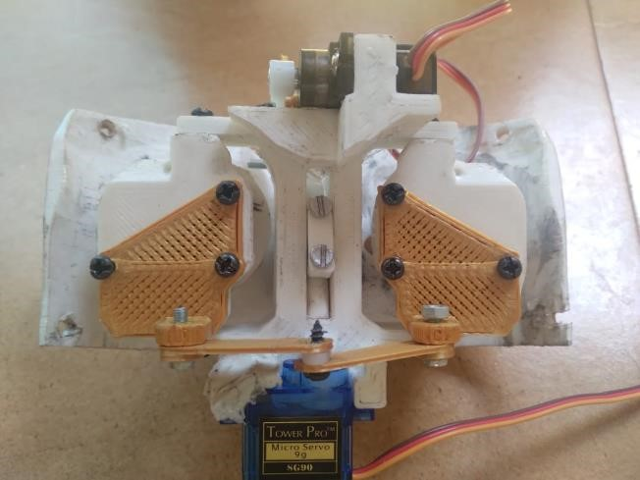

Fig 4.2 Rear view of eyes with Servo

The home position of each servo is initially set to 90 ̊ and each side has a buffer of 30̊ of motion; that is, the range of motion for each servo is defined as 60̊ to 120̊. With the use of a camera in its left eye, the eye can follow the person in front of it. It detects the presence of a face using a face detection module, and it provides a global coordinate that is mapped to the servo between 60 ̊ and 120. The angle provided is fed to a microcontroller via serial ̊ communication. It uses a set of different parts which are given in the Fig 4.3 below.

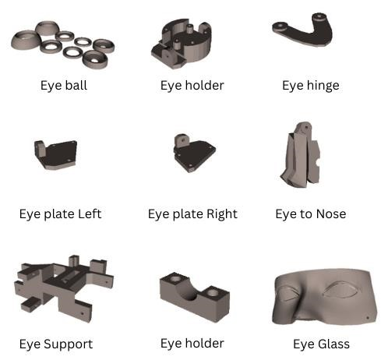

Fig 4.3 Eye mechanism parts used

The main purpose of this mechanism is to resemble animatronic look and mimic the human eye in facial and mechanism. With features like facial recognition and face tracking using OpenCV and python.

**4.1.1.1 Calibration:**

For calibration the servo first is set at at 90, ̊ so that a neutral position is achieved which can be then assembled in the slot. The below Fig 4.4 shows the interface of arduino with servomotor.

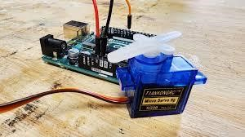

Fig 4.4 Arduino interface with servo

Manual coordinates are entered in the servo to check the maximum range of motion possible for the eye motion.

**4.1.1.2 Eye Mechanism Program Testing**

To test the servo initially a joystick was used to move the servo in “X” and “Y” direction. The face tracking algorithm data is interpreted and mapped to the coordinates of the servo and tested.

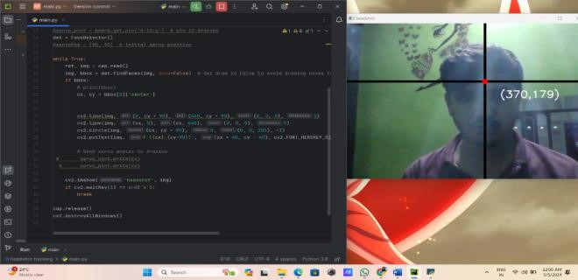

Fig 4.5 Python algorithm for face tracking

#### 4.1.2 Hand Mechanism

The arm serves as the primary mechanism for hand motion and manipulation tasks within the robotic system the project. It provides necessary dexterity and range of motion to grasp objects, perform gestures and interact with the environment.

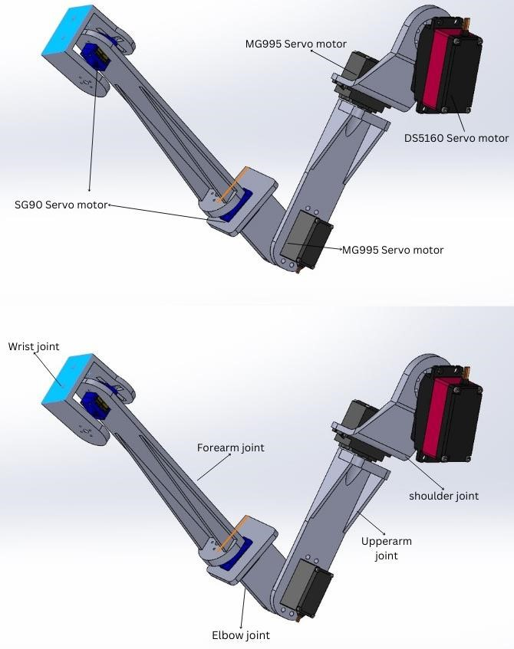

Fig 4.6 CAD image of hand

**4.1.2.1 Technical specification of components used in the hand mechanism.**

Number of Servo motors: 5

Types of joints: Exclusively revolute

Total Degrees of Freedom (DOF): 5

**Table 4.1** **Servo Motor Specification.**

|  |  |  |  |  |
| --- | --- | --- | --- | --- |
| Types of servo motors used | Torque (in kgcm) | Type of motion | Joint connected | No of servo used(per arm) |
| 1.) Ds6150 Servo motor | 60 | Rotary | Shoulder joint | 1 |
| 2.) MG995 Tower pro servo motor | 11 | Rotary | Upper arm joint, elbow joint | 2 |
| 3.) SG90 Servo motor | 1.6 | Rotary | Forearm joint, wrist | 2 |

**4.1.2.2 Discussion of DOF**

The DOF of the arm is known by calculating the DOF associated with each type of motion. The type of motions are -

* A rotary joint: It provides 1 DOF around 1 axis.
* A linear joint: It can provide up to 3 DOF depending on its configuration, enabling movement along 3 different axes.
* A Spherical Joint: It offers 3 DOF enabling movement along 3 perpendicular axes.

The total DOF can be calculated by summing the DOF provided by each joint type and multiplying by the number of joints of that type. In our case it can be considered as below

Number of Rotary joints: 5

Number of Linear joints: 0

Number of Spherical joints: 0

Therefore, the total DOF = (Number of Rotary Joints ˟ DOF per Rotary Joint) + (Number of

Linear Joints ˟ DOF per Linear Joint) + (Number of Spherical Joints ˟ DOF per Spherical Joint)

Total DOF = (5 X 1) + (0 X 0) + (0 X 0)

= 5+ 0 + 0

= 5

Therefore, the total degrees of freedom for the robotic arm is 5.

**4.1.2.3 Controller: Arduino NANO**

To test the range of motion possible for each motor the test is conducted for each joint with a certain motion and assembled it which gives the most smooth and easiest motion.

**Role of Arduino nano in the project**:

The hand mechanism is a specially made part intended to enable five rotary motions necessary for the manipulation activities in the project. It is made up of a skillfully designed system with

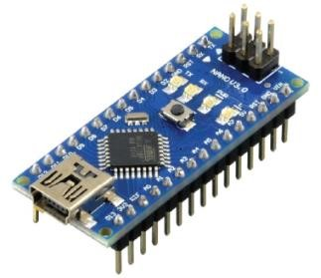

Fig 4.7 Arduino nano [45]

five linked links that work together to produce the desired motion sequences. The mechanism uses servo motors to provide precise control and dependability throughout its operation.

#### 4.1.3 Forward Motion

The project's forward mobility mechanism is essential to the robot's ability to move around and navigate its surroundings effectively. It makes use of two wiper motors that are mounted at one end of the robot's chassis and are upheld by two front-facing caster wheels. Forward motion has been made possible by this system, and it additionally offers stability and maneuverability.

**4.1.3.1 Motor’s used:**

The project uses two wiper motors running at a rpm of 45 at 12V which are rated at 50W. They produce a No-load current at 1.8amp and 5.5 amp at load they have a working speed of 40 RPM.

They are attached with tyres of dia 100mm and 30mm thickness for better traction with the surface. With the help of these data collected there are certain factors which can be calculated which are given below

1. **Running Speed (m/s):**

To calculate the running speed of the robot we need the circumference of the tyres used

Circumference of the tyres = π X diameter = π X 0.1 meters **= 0.1π meters** -------**Eqn 1**

To calculate the speed in Kmph we need the distance it can travel in 1 hour.

Distance traveled per hour = Distance per minute ˟ 60 = 75.39meters ≈ **75 meters**  **------Eqn 2**

Converting meters to kilometers: Distance travelled per hour / 1000

Running speed in km/h ≈ 75 / 1000 km/h = 0.075kmph = **0.02083m/s**

1. **Power consumption:**

The need to measure the power of each motor requires for it to perform without any issue which can be done as follows -

Power used when there is no load = Voltage ˟ Current = 12V ˟1.8A = **21.6W** ----**Eqn 3** Power usage when we apply the load = Voltage ˟ Current = 12V ˟ 5.5A = **66W** -----**Eqn 4** 3. **Torque:**

Torque is a measure of the rotational force applied to an object, causing it to rotate around an axis. To calculate the torque of the motor in order to determine the maximum load carrying capacity -

The formula for torque is -

Torque (τ) = Power (P) / Angular Velocity (ω) ----- **Eqn** **5**

Therefore, Angular Velocity (ω) = 2π ˟ RPM / 60 (since RPM is in minutes) -----**Eqn 6**

Angular Velocity (ω) = (2π ˟ 40) / 60 **≈ 4.188 rad/s** -----**Eqn 7** Hence Torque (τ) = 50W / 4.188 rad/s ≈ **11.94 Nm** -----**Eqn 8**

**4. Efficiency:**

To calculate the effenciency of the motors we need the ratio of output power to the input power

Therefore, Efficiency = (Output Power / Input Power) ˟ 100% -----**Eqn 9**

But Output Power is the mechanical power output by the motor, which is equal to the torque produced multiplied by the angular velocity.

i.e., Output Power = Torque ˟ Angular Velocity -----**Eqn 10**

≈ 11.94 Nm ˟ 4.188 rad/s

≈ **50W**

Input Power is the electrical power input to the motor.

i.e., input power= voltage ˟ current -----**Eqn 11**

input power = 12˟5.5 input power = **66 W**

Hence, Efficiency = (50W / 66W) ˟100%

**≈ 75.76%**

#### 4.1.4 Direction Control of The Robot

To control the robot the principle used is 2-wheel drive. A 2-wheel drive or 2WD system that uses all the 4 wheels in which 2 wheels provide the motion and the other 2 wheels provides stability during the motion.

**4.1.4.1 Forward direction motion:** To achieve the robot’s trajectory in forward direction the rotation of the motor in clockwise direction at constant speed is necessary. And is achieved with the help of the motor driver and a microcontroller.

Clockwise rotation

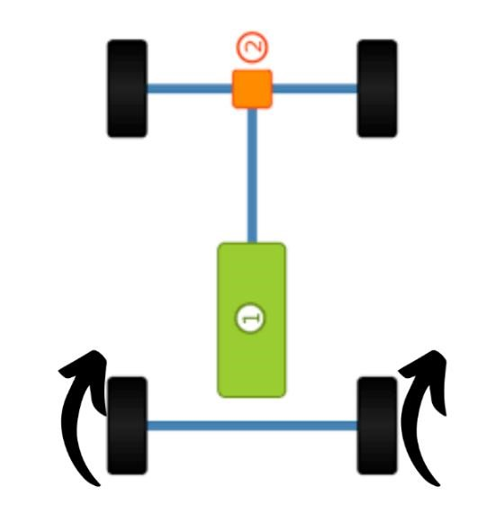

Fig 4.8 Forward direction motion [46]

**4.1.4.2 Backward direction motion**: To achieve the robot’s trajectory in backward direction the rotation of the motor in anticlockwise direction at constant speed is necessary.

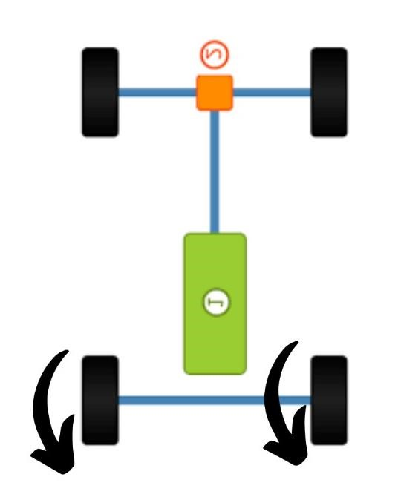

counterclockwise rotation

Fig 4.9 Backward direction motion [46]

**4.1.4.3 Left direction motion**: To achieve the robots trajectory in left direction the rotation of the right motor in clockwise direction and left motor in anticlockwise direction at constant speed is necessary.

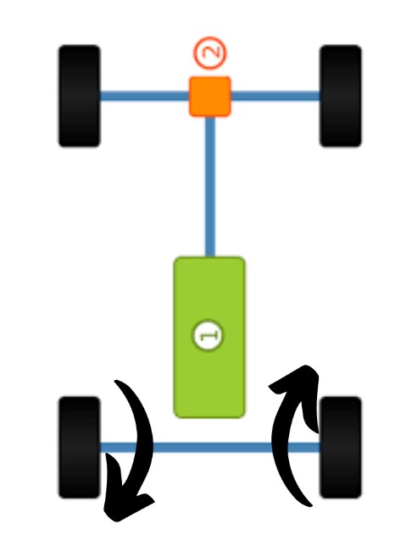 Anticlockwise rotation Clockwise rotation

Fig 4.10 Left direction motion [46]

**4.1.4.4 Right direction motion:** To achieve the robot’s trajectory in left direction the rotation of the left motor in clockwise direction and right motor in anticlockwise direction at constant speed is necessary.

Anticlockwise Rotation

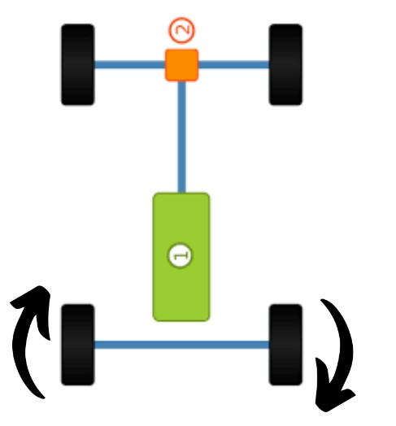

Clockwise Rotation

Fig 4.11 Right direction motion [46]

#### 4.1.5 Face Recognition

The Face recognition is a biometric technique that uses face feature analysis to identify the people. There are multiple steps are involving in the procedure. First, facial landmarkidentifying algorithms are used to detect faces within picture or video frames. Subsequently, distinct features are identified from the identified faces, frequently expressed as numerical information. Neural networks and machine learning algorithms are used to compare these traits against a database of recognized faces. The below fig 4. is show the flow chart of the face recognition. The likelihood of a match is determined based on how similar the extracted features are to the features in the database. Lastly, the comparison results are used to identify or validate the person's identity. Applications for face recognition include surveillance, access control, security systems, and personal device identification.

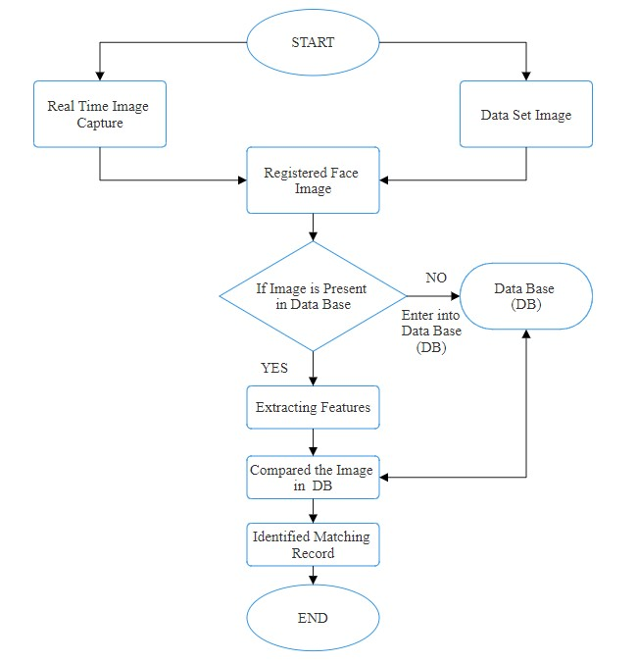

Fig 4.12 Flowchart of the facial recognition

The above Fig shows that how the face recognition is worked in order to create, practice, and implement face recognition systems. A number of tools and libraries are frequently used in face recognition processes.

* **Open CV (OpenSource Computer Vision Library):** The OpenCVis a most popular opensource computer vision library that offers the number of features for processing images and videos, in this library’s such as face recognition, feature extraction, and face detection.



Fig.4.13 OpenCV Library [47]

* **For python3:** Using this command, the OpenCV library for Python 3 is installed. It contains the OpenCV main package and all of its dependencies.



Fig.4.14 Code to install to OpenCV(Pycharm)

* **For additional OpenCV modules (optional):** You can install extra modules or features that go beyond the basic OpenCV library by using the following method.



Fig.4.15 Install extra modules (PyCharm).

* **TensorFlow:** The TensorFlow it is created by Google for the open-source machine learning framework. The neural networks utilized in facial recognition systems are among the machine learning models that can be created, trained, and implemented using its tools.



Fig.4.16 Machine learning model [48]

* **Face Recognition Library:** There are several related face recognition’s libraries are available, such as face recognition using Python library, which provides simple APIs for face detection, and face recognition tasks.

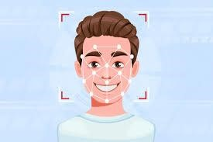

Fig.4.17 Face recognition [49]

**Importance of facial recognition in the project:**

**1. User Identification:** In user identification using facial recognition technology, the humanoid service robots can identify and recognize people through their data base. This feature increases user involvement by adjusting responses and services based on individual preferences and previous interactions.

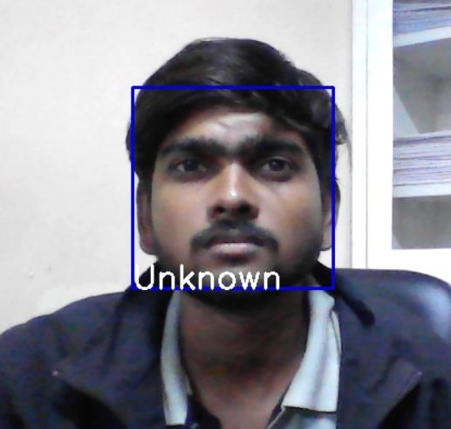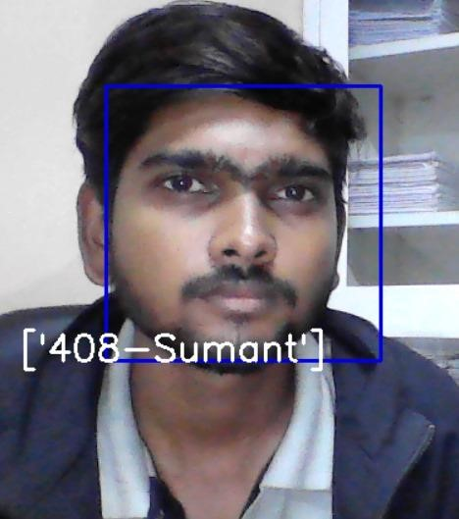

Fig 4.18 Face recognition before Fig 4.19 Face recognition after

**2. Customized Services:** By utilizing facial recognition technology, humanoid service robots may provide customized services according to personal preferences or previous exchanges.

**3. Testing techniques:** In testing techniques to identifying and measure the facial features in the image or videos. In testing techniques there are many types of testing are used few of them are in the below.

**4. Performance Testing:** Performance testing checks how it is quickly and efficiently working with the system and uses its resources. This may be achieved by timing how long it takes the system to identify faces and examining how much memory it uses. Performance standards are set to make sure the system satisfies performance requirements.

**5. Recognition accuracy:** The capacity of a face recognition system to accurately identify or validate people based just on their facial traits is known as recognition accuracy. Usually, it is expressed as the proportion of accurate identifications or verifications among all efforts. When it comes to face recognition, the speed of recognition is the amount of time the system takes to recognize or authenticate a person based just on their facial features. It is an essential component of system performance, especially for real-time applications where prompt action is needed.

#### 4.1.6 Line Following

The line-following mechanism detects the existence of a black line on the ground by means of three infrared (IR) sensors that are positioned strategically along the robot's chassis. The intensity of light reflected back from the surface is measured by these sensors, which emit infrared light. The mechanism identifies where the line is in relation to the robot's trajectory by assessing changes in the intensity of reflected light, and then modifies the robot's motion accordingly. Alignment with the line is maintained by the robot's movement thanks to control algorithms on the ESP32 microcontroller that analyze sensor data.

**4.1.6.1 Turning in line following mode:**

The turning of the robot in line following mode is controlled by the data received by from the IR sensors. If the right sensor is on the black line and left sensor is on the bright surface then it detects and understands that it needs to turn right and

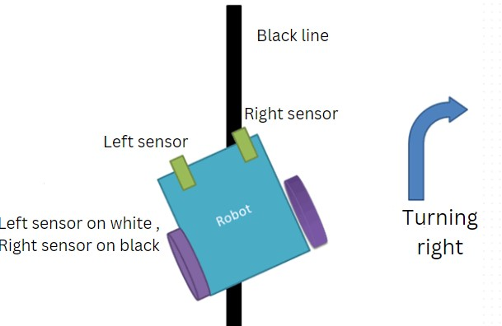

Fig 4.20 Robot turning right [50]

,Similarly if the left sensor is on the black line and right sensor is on the bright surface then it detects and understands that it needs to turn left and

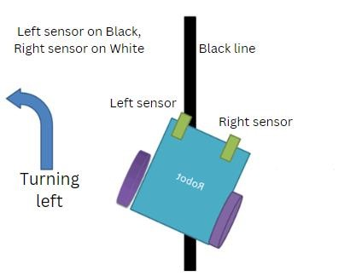

Fig 4.21 Robot turning left [50]

And if both the sensor are on the bright surface then there is no need for turning and it follows a straight path.

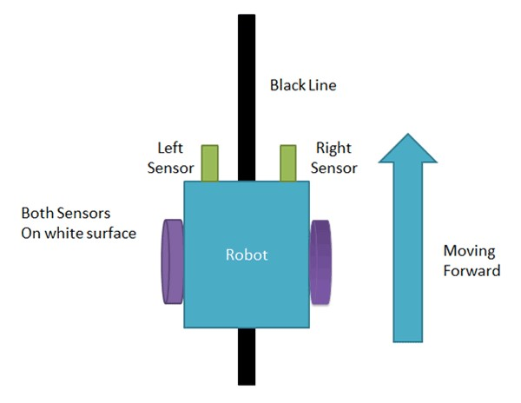

Fig 4.22 Robot moving forward [50]

It was crucial to change the sensor's height above the ground and ensure that each one was set to active low in order to test the line following mechanism's accuracy. When a black line is detected, the sensor sends a high pulse to the controller, which uses the PID algorithm to steer the robot's trajectory and keep the center sensor on the black line while the other sensors stay off of it.

**CHAPTER 5**

## APPLICATION DEVELOPMENT

The process of gathering business requirements, creating, prototyping, developing, testing, and continuously improving and debugging software is known as application development. Modern application development embraces agility, reliability, and security. Using highly customized technologies that focus on human centred design, project provides application that focus on your serving people.

The project application focuses on mainly the below mentioned mechanisms

* Eye Mechanism
* Motion Mechanism.
* Hand Mechanism

Giving the project the tools it needs to produce high-quality goods on time, adapt quickly to changing consumer needs (like switching between the line following to motion to eye movement). Agility, dependability, and security are all embraced in this project.

### 5.1 Overview of The Mobile Application

The app uses application software as the main building block as application software enables to develop for specific uses alone.

Application software is helps end users execute specified tasks. It is a product or program designed specifically to fulfil the needs of end consumers .it includes eye motion, arm motion and robocar motion combined or individually.

Python programming language is easy as it does not follow particular syntax and has multiple libraries that support complex functions like face recognition, voice detection like open cv modules.

The project uses such technical coding for the robot to function and thus make it versatile. The most convenient language was python programming language as it does not take lot of time to learn and code things appropriately and efficiently and also debugging in python becomes easy compared to any other programming languages.

### 5.2 Mobile Application Development

The process of creating software for smartphones, tablets, and digital assistants— most often for the Android and iOS operating systems—is known as mobile application development.

The software can be accessed via a mobile web browser, downloaded from a mobile app store, or preinstalled on the device. The programming and markup languages used for this kind of software development include Java, Swift, C# and HTML5.

Mobile app development is quickly developing. Organizations in a variety of sectors, including government, insurance, healthcare, and retail, telecommunications, and e-commerce, need to satisfy consumer expectations for quick, easy ways to conduct business and obtain information.

Thus, the project uses the mobile application for its most of the movements that would provide services to the common people at affordable cost.

The most widely used method for individuals and companies to access the internet these days is through mobile devices and the applications that maximize their potential. Project aims to create the mobile applications that their partners, consumers, and staff want if wanted it to remain successful, relevant, and responsive.

There are two ways to code for an application one is by using programming languages and two by using block codes. The project uses block coding as its backbone for application development.

The block coding has an advantage of easiness in programming for non-programmers as well as for beginners thus app development was easy and fast.

### 5.3 MIT App Inventor

A high-level block-based visual programming language called MIT App Inventor (also known as MIT AI2) was created by Google at first and is currently maintained by the Massachusetts Institute of Technology. It enables novices to develop computer programs for the two operating systems iOS and Android which are currently in beta testing as of September 25, 2023. It is open-source and free [51].

Like Scratch, its primary audience consists students learning computer programming.

Project uses design applications that can be tested on Android devices and compiled to operate as Android apps using the web interface, which has a graphical user interface (GUI) that is very similar to Scratch and Star Logo. It makes use of the MIT AI2 Companion smartphone app, which offers live testing and debugging.

App Inventor offers connectivity with a variety of web services, including Firebase and Google Sheets.

Google drew on extensive earlier research in educational computing as well as internal work on online development environments while developing App Inventor. Project has a combined application for eye movement, motion control and hand movement where there is incorporation of multiple layouts that would take the user control to the respective handling page for respective movements.

There are basically three layouts:

1. Motion control
2. Eye movement
3. Arm movement

**5.3.1 Motion Control:**

The motion control of the robot can be achieved via the app created in MIT app Inventor

* The over view of the page visible for the end users to control the lower body motion of the robot.
* Project has a Bluetooth connected to the mobile and operated and controlled by the mobile application and thus provides the proper control via buttons and tabs as shown in the Fig 5.1 below
* The layout saying **“AVAILABLE DEVICES”** will have shown devices and the buttons that are to be depressed for the motion of the robot (left, right , forward and backward)
* Show devices depressed will show the available devices with the Bluetooth on and then connect to the device and then start using the layouts for movements.
* The robot operates forward with F button depressed and moves left and right for L and R depressed respectively.
* S button would stop the robot under emergency or if the end users would really like to stop robot operation.

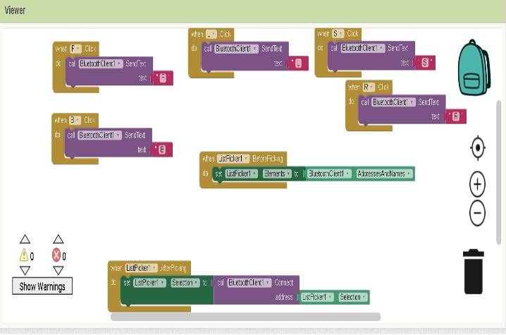

Fig 5.1 Describes the block coding part of the motion control application

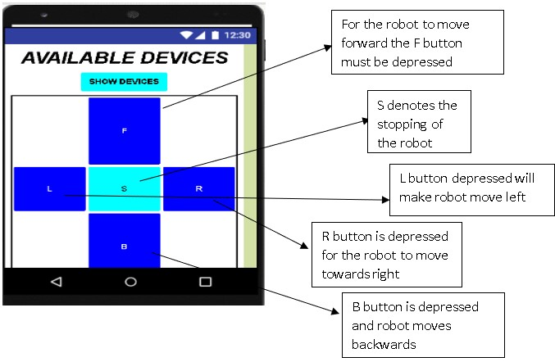

Fig 5.2 Shows the application layout for the motion control

**5.3.2 Eye Movement -**

The eye movement is provided with a slider-based selection of the direction of rotation of the eye in both x direction and y direction respectively.

* The thumb position of the slider is set 90 degree and then made to have movement in X – Y within the window of 60 degree to 120 degree.
* The slider adjustments can be done to set the direction of the eye either towards “X” or “Y” direction

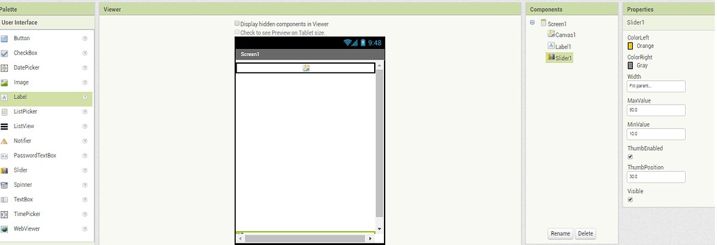

Fig 5.3 Shows the layout preparation in MIT App Inventor

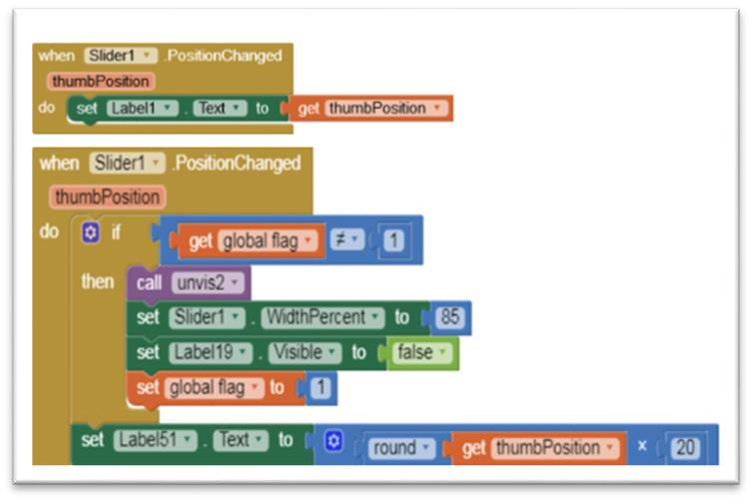

Fig 5.4 Shows the block coding of the eye movement application

**5.3.3 Arm movement**

The arm movement is provided with a slider-based selection of the direction of rotation of the arm in each joint.

* The robot can make five handily movements that are facilitated by mobile application that has been developed.
* The robot Is equipped with 5 motors having to with do 5 joints movement.

* The robot gripper, wrist pitch, wrist roll, and elbow, waist, shoulder etc are given different sliders with the help of which the end user can make the robot arm move in 5 individuals movements as shown in the Fig 5.5 below.
* The thumb position of the slider is set to 90 degrees and from there is a joy stick provided which it helps the forward and backward movement of the arm.
* The robot can work with the help of “taught” instructions where the application works as a teach pendant.
* Then when instruction is given, they can be saved and made to run for repetitive jobs if necessary.

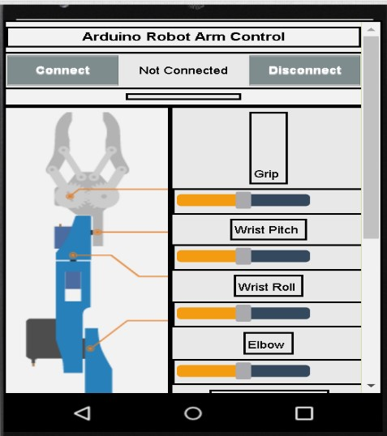

Fig 5.5 Describes the arm servo motion and movement

The block code to control the 5 individual Servo motors is shown in the Fig 5.6 below. Each function is a set instruction for the microcontroller to follow to control the arm with ease. The save and run feature allows the microcontroller to store the current coordinates of each servo for repetitive work allowing feasibility.

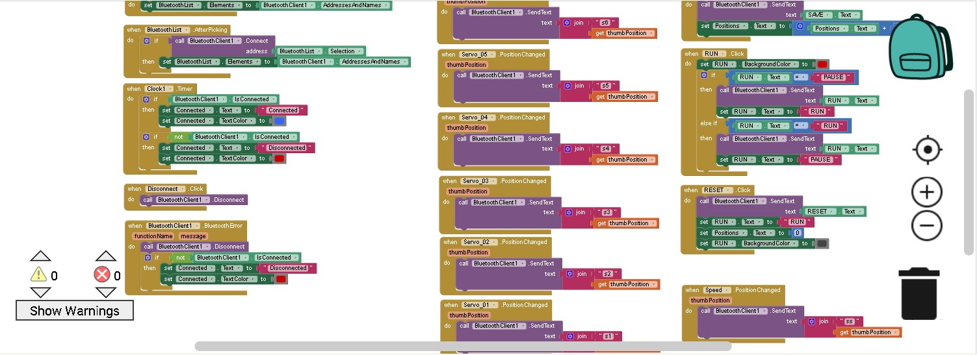

Fig 5.6 Describes the block coding for the arm motion in MIT app Inventor

**Chapter 6**

## RESULTS AND DISCUSSION

### 6.1 Eye Mechanism

The eye mechanism developed and tested demonstrates successful integration of hardware and software components, resulting in a vision system capable of tracking and detecting faces effectively while providing smooth motion. Utilizing parts from INMOOV's mechanism, such as SG90 servos and an Arduino Uno, alongside Python programming for flexible control via serial communication, the mechanism achieves a lifelike appearance and functionality. This capability to replicate human senses enhances its utility across various applications, including assistive technology, surveillance systems, and human-robot interaction.

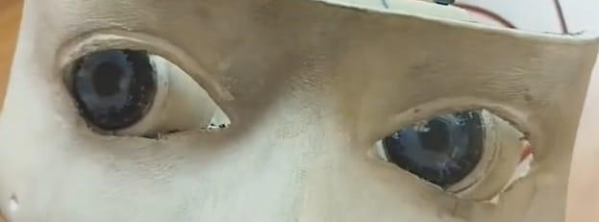

Fig 6.1 Eye movement before Fig 6.2 Eye movement after

**Result:**

The Eye mechanism system has been successfully implemented, utilizing hardware and software to build the vision system able to easily track and detect faces. We create an actual functional system by integrating INMOOV mechanism components.

**Discussion:**

* Component Integration is the combination of SG90 servos, Arduino Uno, And Python resulting in a smooth and effective vision system.
* Realistic and Functional Design is the real eye mechanism that increases the assistive technology interaction between humans and robots.
* Wide Application is effectively face-tracking and face-detection making it valuable in assistive technology.

### 6.2 Hand Mechanism

The hand mechanism demonstrates successful functionality across its five degrees of motion, utilizing potentiometers for precise servo control. A custom-built teach pendant enhances user interaction, offering tactile control for intuitive manipulation. Through strategic servo selection based on torque requirements, including a 60kgcm servo for shoulder movement and lighter servos for subsequent joints, the mechanism achieves efficient load handling. With control options ranging from manual operation via the teach pendant to remote control via Bluetooth serial communication, the hand mechanism offers flexibility and versatility in its operation.

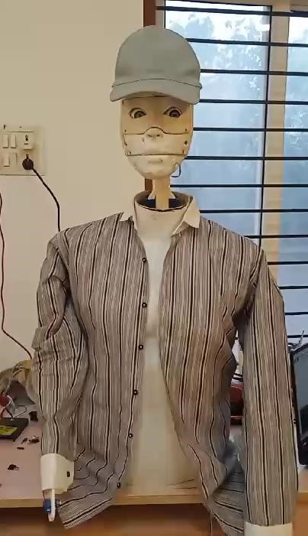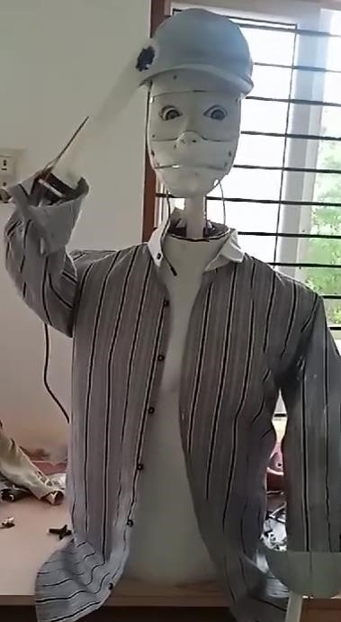

Fig 6.3 Hand mechanism before Fig 6.4 Hand mechanism

**Result:** The hand mechanism is effective and accurate control over the five degrees of motion. Potentiometers ensure accurate servo control and a unique teach pendent provides simple interaction with servos. Which servos are based on torque requirements, and ability to handle load.

**Discussion:**

* Effective and Accurate Control is the hand mechanism that accurately controls motion across five degrees to ensure consistency that can be seen in Fig 6.3 above.
* Potentiometers provide precise servo control, improving the mechanism’s accuracy and speed.
* A one-of-a-kind teach pendant allows for a simple, connection with the servos, making it easy to use.

### 6.3 Forward motion

The forward motion system employs two wiper motors operating at a speed of 45rpm, regulated by a 15amp motor driver controlled by an ESP32 microcontroller. The mechanism, situated at the rear end of the frame, is stabilized by two caster wheels at the front. Bluetooth control with speed adjustment facilitates precise maneuvering. With its robust torque capabilities, the wiper motors can reliably bear loads of up to 20-30kg without encountering any issues.

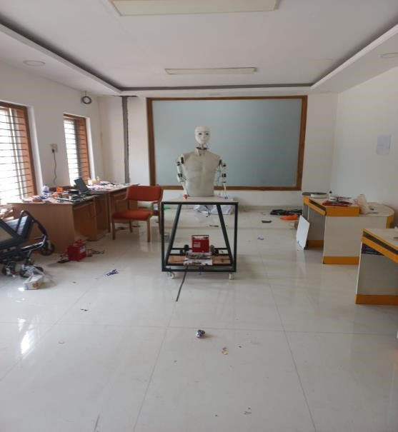 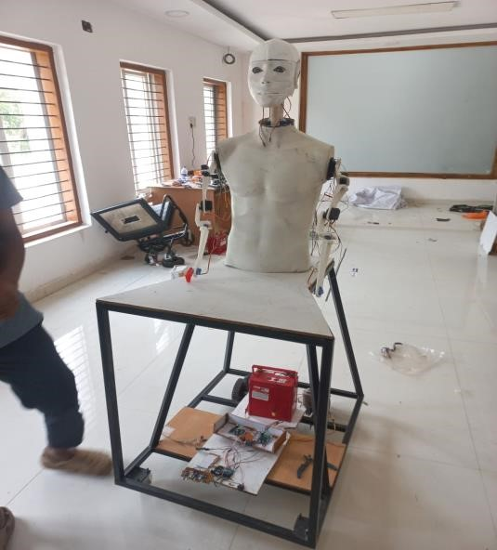

Fig 6.5 Forward motion Before Fig 6.5 Forward motion after

**Result:**

The forward motion system uses two wiper motors for a steady 45rpm speed, controlled by a 15amp motor driver and ESP32 microcontroller for smooth operation. Front caster wheels provide stability. Bluetooth control allows precise navigation, and the system handles 20-30kg loads without performance loss.

**Discussion:**

* Steady speed it has two wiper motors that ensure a constant speed at 45rpm for reliable forward motion.
* For smooth control a 15amp motor driver and ESP32 microcontroller provide smooth operation.
* The front caster wheels add stability and support during the movement.
* When a forward command is given to the robot it takes a single bit of data and accordingly can move for a distance of 10m as shown in Fig 6.5 and Fig 6.6.

### 6.4 Face Recognition and Tracking

The face recognition system employs Python, OpenCV, and PyFirmata for serial communication with Arduino. Utilizing OpenCV's face detection module, the system detects the presence of a face as shown in Fig 6.7 and Fig 6.8 below also it tracks accordingly. Data containing coordinates for servo control is sent to the Arduino, facilitating precise tracking of the detected face.

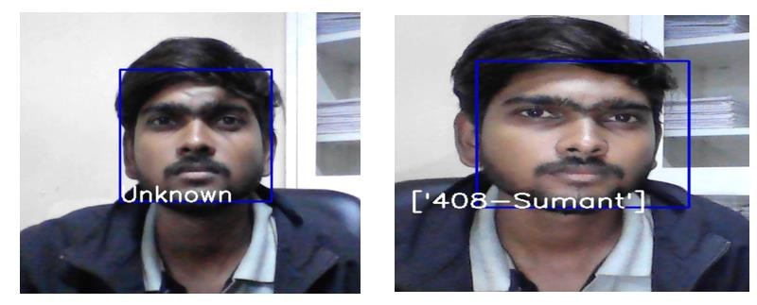

Fig 6.7 Face recognition before Fig 6.8 Face recognition after

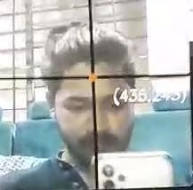 

Fig 6.9 Face tracking before Fig 6.10 Face tracking after

**Result:**

The facial recognition system has been successfully built, with Python and OpenCV for face detection and tracking. It check for the database for the facial feature stored previously if the user is present in the database then it displays the name on the screen as shown in Fig 6.8.

**Discussion:**

* The facial recognition system is effectively built using Python and OpenCV technologies.
* Python and OpenCV provide robust face detection capabilities for accurate identification.
* The face tracking system reliably tracks faces, ensuring continuous monitoring and recognition.

### 6.5 Line following

The line-following system utilizes three IR sensors in conjunction with the same controller used for forward motion. These sensors enable the system to detect and follow lines on the ground, facilitating autonomous navigation in predefined paths.

**Result:**

The line-following system uses three IR(Infrared) sensors and a controller for forward motion, allowing autonomous navigation along the specified path by detecting and following lines on the ground.

**Discussion:**

* IR (Infrared) sensors detect lines and properly guide the system along the specified path.
* The controller evaluates sensor data to allow self-guided movement.
* The system may respond to different variable navigation features.

### 6.6 Text-to-speech

The text-to-speech technology translates written information into spoken words making it convenient for a variety of applications. The key components are a text input, a processing engine, and an audio output. The processing engine understands the text, converts it into spoken words, and delivers it through an audio output device. This technology improves accessibility and communication for various applications. Here are some pre-commands given below which robot react or respond to humans.

Q: "How are you?"

A: "I am fine, how about you"

Q: “What can you do?”

A: "I can assist you with various tasks, like answering questions, setting reminders, and more."

Q: "How old are you"

A: "I am as old as the software version I am running on."

Q: "How do you work?"

A: "I work by processing your voice commands and responding with relevant information."

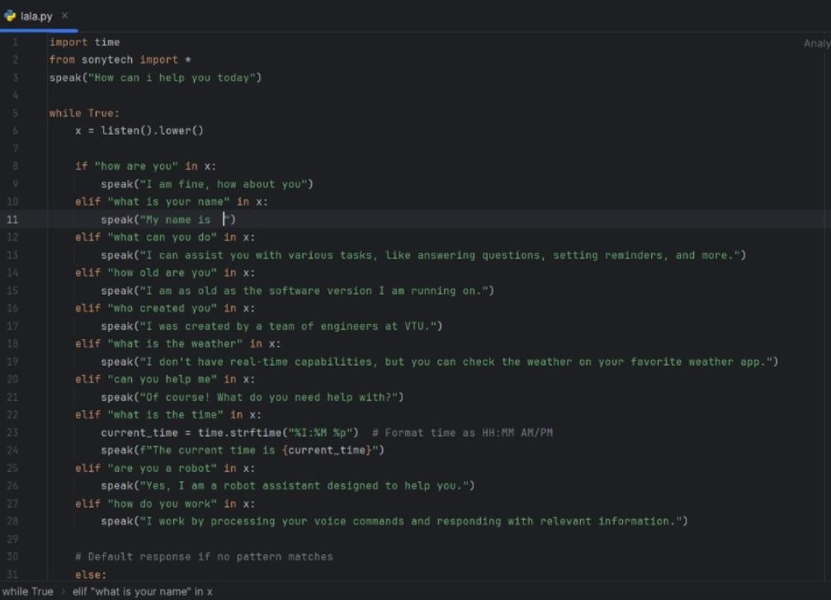

Fig 6.11 Text to Speech Code

**Result:**

In text-to-speech technology converts written words making it a useful variety of applications. This technology serves education, entertainment, and telecommunication by providing simple and easy audio output from text information.

**Discussion:**

* The text-to-speech depends upon how much pre commands are uploaded to the database.
* It is flexible in programming code pre command which can be changed based on the application.
* It helps the daily routine life of humans by assisting like reminders, weather forecasting, etc.

**Chapter 7**

## CONCLUSION AND FUTURE SCOPE

### 7.1 CONCLUSION

Due to the significant increase in the need for robotics and advanced technology in industry, it is necessary to educate people about new technologies like service-based robot creation and usage. The creation of humanoid robots has opened up new avenues for robotics research and development. Because of their human-like look, users are more at ease and flexible with the robot, which enhances their appeal.

The Whole Robot is manufactured using the 3D printing, FRP and Manufacturing. The supporting the Mechanism also done by versatile a servo meter and chip to minimize the cost of the whole robot. So that the ultimate cost can be reduced to the 40 – 50 % percentage of conventional market price which around 25,000 to 30,000/- is overall cost of manufacturing where the market price is 1,25,000/- to 2,00,000/-.

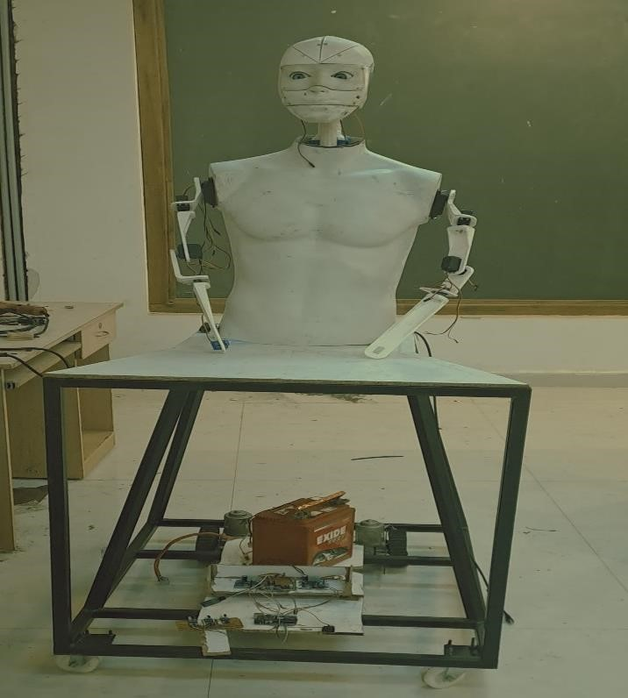

Fig 7.1 Assembly of Robot

The objectives of the entire project have been met, some of those objectives are highlighted below

1. **Low Budget:**

The project's capacity to finish all necessary features at a price far less than the competition demonstrates how successful our plan was. By intelligently combining FRP and additive manufacturing, we were able to achieve significant cost savings while maintaining high levels of quality and functionality in the finished product, which also set a new standard for affordability in the industry. This accomplishment shows our dedication to affordable innovation and establishes us as industry leaders in providing solutions that are easy to use without sacrificing durability or performance.

1. **Versatile Mechanisms:**

The extensive testing carried out on a variety of mechanisms demonstrates our dedication to providing a sturdy and dependable robotic platform. Every mechanism has been carefully examined, from complex arm movements to line following, to guarantee smooth operation in a variety of settings and jobs. This methodical approach not only improves the robot's performance but also gives users confidence in its ability to successfully handle obstacles in the real world.

1. **Wireless Serial Communication:**

Wireless serial communication capabilities have been integrated into the robot's control system, providing users with an unprecedented level of convenience and flexibility. With this capability, we may improve operational efficiency and adaptability in a variety of settings and ultimately redefine our interactions with robotic systems, whether it is through remote operation from a distance or seamless integration into larger networked systems.

1. **Custom Teach Pendant for Arm Control:**

The commitment towards offering clear and exact control over the robot's manipulating abilities is demonstrated by the creation of a personalized teach pendant. Above and beyond simple manual control, this custom interface allows users to precisely modify every joint on the robot's arm, allowing for more complex tasks to be completed with ease. Its function goes beyond modeling and testing; it is a vital component in enabling the robot to reach its maximum potential in real-world scenarios where accuracy and adaptability are critical.

1. **Face Recognition and Tracking:**

The robot has sophisticated face recognition and tracking algorithms installed. By reliably recognizing saved faces and extending greetings to people according to the time of day, the face recognition module improves user experience and interaction. Furthermore, the robot's adaptability and engagement abilities are improved by the face tracking capability, which allows it to dynamically track and follow faces within its field of view utilizing servo-controlled motions.

#### 7.1.1 Outcome of project work

**Article 1: “**Design of Low-Cost Humanoid Robot for Serving Application”

1. **1.2 Funding:**

Project funding received from **Karnataka State Council for Science and Technology** of47th Series of student project program 2023-24



**7.2 Future scope:**

* The weight carrying capacity is initially designed for 500 grams, but it can be significantly increased to accommodate multiple kilograms by redesigning the structure and incorporating more powerful servo motors.
* Movement control can be significantly advanced by integrating IoT (Internet of Things) technology into the system.
* Additional features such as face recognition, emotion detection, chatbots, and attendance systems can be integrated into the humanoid robot to enhance its capabilities.
* The application of the robot can be modified to suit specific conditions or task requirements as needed.
* The overall body weight and mechanism can be adjusted and optimized to fulfill the requirements of various tasks.

**7.3 BILL OF MATERIAL**

|  |  |  |  |
| --- | --- | --- | --- |
| **Sl no** | **Component** | **Quantity** | **Price (in Rs)** |
| 1 | Wiper motor | 2 | 2500 |
| 2 | Caster wheel | 2 | 400 |
| 3 | MS frame | Fabrication | 4000 |
| 4 | 15amp motor driver | 1 | 2500 |
| 5 | Esp32 | 1 | 400 |
| 6 | Arduino | 3 | 1200 |
| 7 | SG90 servo | 6 | 900 |
| 8 | Mg995 servo | 5 | 1500 |
| 9 | DS5160 servo | 2 | 3600 |
| 10 | High torque tower pro servo | 1 | 1090 |
| 11 | 3D printing | Overall parts | 5000 |
| 12 | Fiber body | 1 | 1500 |
| 13 | Miscellaneous (nuts,bolts, Connectors,wires,tools) | - | 1500-2000 |
|  |  | Total = | Rs.26090-26690 |

**Note:**

* + - The above rates are market dependent as of May 2024.
    - Miscellaneous and 3D printing rates are approximate.

## REFERENCES

1. <https://images.app.goo.gl/JRntEs8dGRss3xcH6>
2. https://www.scirp.org/journal/paperinformation?paperid=90517
3. https://www.scirp.org/journal/paperinformation?paperid=90517
4. https://www.scirp.org/journal/paperinformation?paperid=90517
5. https://www.scirp.org/journal/paperinformation?paperid=90517
6. https://www.javatpoint.com/robotics-historyA Brief History of Industrial Robotics in the 20th https://www.scirp.org/journal/paperinformation?paperid=90517
7. <https://en.wikipedia.org/wiki/Robot>https://www.scirp.org/journal/paperinformation?paperid=90517
8. <https://www.javatpoint.com/robotics-history>
9. <https://www.javatpoint.com/robotics-history>
10. <https://stemrobotics.cs.pdx.edu/sites/default/files/History_of_Robotics.pdf>
11. <https://www.scirp.org/journal/paperinformation?paperid=9051>
12. <https://www.scirp.org/journal/paperinformation?paperid=9051>
13. <https://www.scirp.org/journal/paperinformation?paperid=9051>
14. <https://www.servicerobots.com/blog/service-robots/>
15. <https://www.javatpoint.com/robotics-history>
16. <https://builtin.com/robotics/humanoid-robots>
17. https://images.app.goo.gl/xxgSRtt6qAhnHbrQA
18. https://images.app.goo.gl/DBwdCEidt4NWkeP4A
19. <https://images.app.goo.gl/h2LBqAUvncHCzsJT6>
20. https://images.app.goo.gl/7LgRj3ANfh2nxs1h8
21. <https://multisite.eos.ncsu.edu/www-ergocenter-ncsu-edu/wp-> content/uploads/sites/18/2016/06/Anthropometric-Detailed-Data-Tables.pdf
22. <https://images.app.goo.gl/LtcHXc7reseVcBQX8>
23. <https://images.app.goo.gl/N9Hb5LNuC4D89PTR7>
24. <https://images.app.goo.gl/35ynaGKpoyH2crCW9>44. https://images.app.goo.gl/k8YjbhuQa9TwifdP6
25. <https://images.app.goo.gl/uJCvz7Xu8ab1u8QA9>
26. <https://images.app.goo.gl/uZeX4TAs4HmRN8fU9>
27. <https://images.app.goo.gl/ih6hmskWCecn1qJE8>
28. https://images.app.goo.gl/jiD9PMpJ2WiMPj8Y9
29. <https://images.app.goo.gl/ZNwdKLZZX3x14ZZ86>
30. <https://images.app.goo.gl/Sp2EAERVsyioPWVt6>
31. <https://code.appinventor.mit.edu/?locale=en#5368121406265120445>